**Invitation to Bid (ITB)**

SGOA/ITB/UNWOMEN/001

**Sustainable Goals Organization for Afghanistan (SGOA)** needs the provision of poultry farming materials in Kandahar Province and invites interested parties to submit their sealed offers for the required items mentioned in Annex (I).

Sealed offers must reach the SGOA Main Office Operation Unit located in **House #131, 6th Sub Avenue, 26th General Street, 2nd Aino Mena, Kandahar Province**, by **4:00 PM, Jan 30, 2025**.

The bid opening session will be held on **Feb,01, 2025, at 10:00 AM** in SGOA Main Office, Kandahar Province, and the winner of the bidding will be notified shortly after the bid opening session.

**Terms and Conditions for Participation/Bid Winner**

1. Delivery place of the poultry farming materials is at the SGOA Main Office/ or any place selected by SGOA in Kandahar Province.
2. Payment will be made within 25 working days after inspection and complete delivery.
3. Delivery will be done based on the tentative delivery plan mentioned in Annex (II).
4. Prices shall be given in USD ($) and must include all duties, transport costs, loading, and unloading costs. Offers must be original in hard copy with company sign and stamp. Manipulated/overwritten and copied offers will automatically be rejected.
5. SGOA will carry out technical inspection of all items before and after the delivery.
6. All items must be according to SGOA Technical Specifications mentioned in Annex (I).
7. The bid winner must deposit **10% of the total contract value** to the SGOA bank account as a **Contract Performance Guarantee** before signing the genuine contract. The mentioned amount is refundable after the successful completion of the contract.
8. Quotations should be valid for **45 working days**.
9. In case of delay without any logical reasons in the delivery of items, **0.5% of the total cost** of undelivered items will be charged as a penalty for each day of delay.
10. **2% Tax** will be applicable to companies with a valid business license, and **7% Tax** will be applicable to companies with an invalid business license or individuals without a business license. The tax will be deducted from the contractor and paid to the Ministry of Finance by SGOA.
11. All bidders should deposit **$500 USD** to the SGOA Ghazanfar Bank USD Account (**I129120000142 USD**) as a **Bid Security**; otherwise, SGOA has the right to make a decision.

**Note:** All deposits (Bid Security/Contract Performance Guarantee) will be refunded upon proper application of vendors along with the original bank deposit slip. Deposits will not be refunded if the supplier/bidder withdraws or quits the process.

1. SGOA will not be responsible for changes during the contract, such as (increment in custom duties, exchange rate, etc.).
2. Award of the contract will be based on the **price, quality, capacity, and potentiality** of the bidder. The evaluation of bidders and their products will be carried out. SGOA reserves the right to decide on awarding the contract.
3. The SGOA Logistics Unit adheres to **National and International laws on child labor** and ensures all its suppliers and vendors abide by such laws.
4. The Humanitarian Organizations (HO) may conduct on-site visits to the contractor’s premises (or take similar measures) to ensure compliance.
5. The bid winner must deliver the contracted materials without changes until the end of the contract.

For more details, please visit SGOA Operation Unit Main Office, Kandahar, Sunday through Thursday, from 8:30 AM to 4:00 PM, or contact the below email address:  
[**operations@sgoa-af.org**](mailto:operations@sgoa-af.org)

Sincerely Yours,  
**Operation Officer**

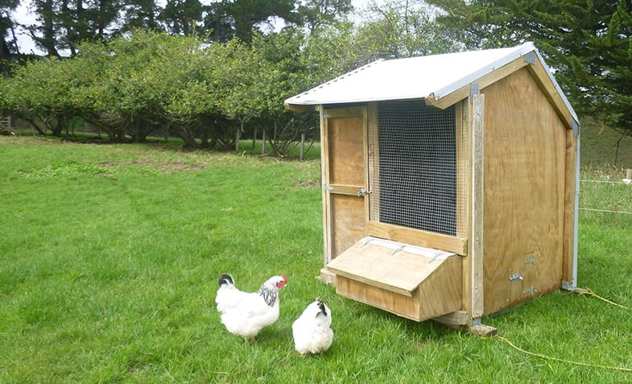**Annex I  
  
The cage should be 2 pcs of 2*2 meter for 55 families and each cage should be covered with four side with plywood and Styrofoam for heat and cold resistant and covered with hard plastic sheets for rain and dust resistant**

**ANNEX (I)**

**Form for Breakdown Budget / SGOA/ITB/UNWOMEN/001**

|  |  |  |  |  |  |  |
| --- | --- | --- | --- | --- | --- | --- |
| **S.N** | **Item Name** | **Specifications** | **Unit** | **Total Quantity** | **Unit Cost Including 2/7% Government Tax (USD)** | **Total Cost Including 2/7% Government Tax (USD)** |
| 1 | Egg-laying chickens | Golden Misry, 4-6 months old, average weight 1 kg already should egging started | Chicken | 2,200 |  |  |
| 2 | Chicken feed | Feed 13th No, suitable for egg-laying chickens | Kg | 5,500 |  |  |
| 3 | Chicken water feeders | Standard quality made from plastic/steel | Piece | 110 |  |  |
| 4 | Chicken food feeders | Standard quality made from plastic/steel | Piece | 110 |  |  |
| 5 | Vaccines | NDIB, IBD, ND Lasota, IND Clon, Gambro Plus (Vials Sets) | Set | 110 |  |  |
| 6 | Wooden chicken cages | 2m x 2m with 1 meter hight, heat/cold proof with Styrofoam and plastic sheet-covered ceiling and small door | Piece | 110 |  |  |
| 7 | Transportation | Transport of chickens and tools from farm to beneficiaries’ location in Kandahar city | Trip | As needed |  |  |

**Grand Total: USD**

**Bidder Name:** _____________________________________________________________________________________________  
**Address and Stamp:** _____________________________________________________________________________________________  
**Contact No/Email Address:** _____________________________________________________________________________________________  
**Delivery Period:** _____________________________________________________________________________________________