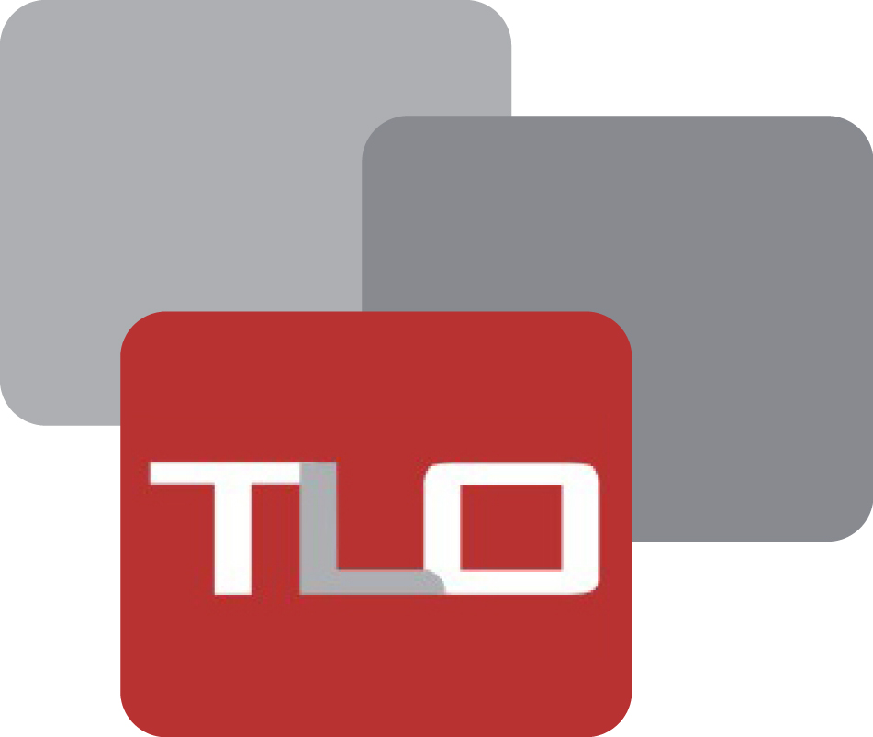

**RFQ No: TLO-RFQ-010-2025**

**Request for Quotations (RFQ)**

**Market System Development Tools for Paktika and Daikundi**

**Project Title: CSRLS**

**Issue on:13th Jan 2025**

**Closing on: 19th Jan 2025 (10:00 am)**

**Introduction:**

**The Liaison Office (TLO)**

The Liaison Office (TLO) is an independent Afghan non-governmental organization established in 2003 and seeking to improve local governance, stability, and security through systematic and institutionalized engagement with customary structures, local communities, and civil society groups. TLO’s main areas of activity are Research/Analysis using the do-no-harm approach; Dialogue Facilitation/Peacebuilding; Access to Justice; and livelihood improvement. In addition to the TLO headquarters in Kabul, the organization has a regional office in Paktia-Southeast, a provincial office in Khost, and multiple project offices across Afghanistan, with over 117 staff. Current and recent TLO funders include the United States Institute of Peace, USAID, the Open Society Institute, DAI (including projects contracted from USAID), and GIZ, along with the governments of Australia (AusAid), Germany, the Netherlands, Norway, Switzerland (SDC), Canada, UNHCR, Cordaid, UNICEF, SIDA and ECW.

**Activities/ Tasks**

Only Livestock, Agriculture, Logistic, and Trading Companies should provide Hard Copy of Quotations for the supply of items listed below:

**Specifications:**

Equipment for Dairy Producer Tools for Zurmat, Mata Khan, and Urgon Districts of Loya Paktia Province

|  |  |  |  |  |  |
| --- | --- | --- | --- | --- | --- |
| **SR#** | **Description** | **Qty** | **UoM** | **Unit Cost AFN** | **Total Cost AFN** |
| 1 | Small Strainers | PCs | 900 |  |  |
| 2 | Small bucket for milking for the producer, capacity 7-10L, and metal steel (Nickel) or aluminum | PCs | 900 |  |  |
| 3 | Small drum for transferring milk to the MC-N, capacity 7-10L, and metal steel (Nickel) or aluminum | PCs | 900 |  |  |
| Sub Total in AFN | | | | |  |

Equipment for Dairy Producer Tools for Sharistan and Nili Districts of Daikundi Province

|  |  |  |  |  |  |
| --- | --- | --- | --- | --- | --- |
| **SR#** | **Description** | **Qty** | **UoM** | **Unit Cost AFN** | **Total Cost AFN** |
| 1 | Small Strainers | PCs | 600 |  |  |
| 2 | Small bucket for milking for the producer, capacity 7-10L, and metal steel (Nickel) or aluminum | PCs | 600 |  |  |
| 3 | Small drum for transferring milk to the MC-N, capacity 7-10L, and metal steel (Nickel) or aluminum | PCs | 600 |  |  |
| Sub Total in AFN | | | | |  |

|  |  |
| --- | --- |
| Equipment for Dairy Producer Tools for Loya Paktika Province |  |
| Equipment for Dairy Producer Tools for Daikundi Province |  |
| **Grand Total in AFN** |  |

**Eligibility, Evaluation, and Requests for Information**

Only those companies that:

* Possess a valid business license

For their bids to be considered “responsive” and be evaluated for award, qualified Offers must:

1. Submit all information required below on or before the time/date mentioned.
2. Demonstrate the capability (supported by client references and/or literature) to meet the requirements specified in the Statement of Work.
3. Have a satisfactory record of Past Performance. (Attaching the Contract/Purchase Order with Completion Certificate, GRN, to the RFQ is recommended)

**Content and Format of Your Proposal**

For TLO to conduct the most efficient analysis of proposals received, please format your response as follows:

1. A letter of transmittal confirming:
   1. Your company’s status is that of a licensed firm with AISA/Ministry of Commerce.
   2. The validity of your proposal/Quotes for a minimum of Ninety (90) calendar days. The letter must be signed by someone authorized to bind your company and negotiate on your company’s behalf.
2. A discussion of your approach to providing the required services. You must meet ALL the requirements.
3. A description of your company’s capabilities to provide the required goods, including evidence of financial responsibility and other Governmental Regulatory licenses.
4. The successful offer will receive a fixed-price contract for the period stipulated in this RFP. The fixed prices will remain in effect for the entire Period of Performance unless modified in writing by TLO.

Rates should be presented in **AFN.**

**TIME FRAME**

The purpose of this RFQ is to identify and hire a vendor to provide the above-listed goods.

**Service / Product Delivery and Payment Terms**:

* **Payment method:** The supplier will be paid through a Business bank Account after satisfactory delivery (no advance payment to the vendors).
* **Delivery timeline:** 30 days following the contract is issued
* **Mode of Shipment:** DDP
* **Delivery Addresses:**
* Zurmat, Mata Khan, and Urgon Districts of Loya Paktia Province
* Sharistan and Nili Districts of Daikundi Province

**Submission of Quotation:**

The deadline for submission of sealed hard copies of offers is 19th Jan 2025/ 10:00 AM Local Time. (Kabul, Afghanistan time) at the address: House # 38, Street # 06, Taimani Watt Kabul-Afghanistan. Please reference this **(TLO-RFQ-010-2025)** on the sealed envelopes.

RFQ received after the deadline may not be considered. Proposals must be valid for a minimum of Ninety (90) calendar days.

**Questions and Clarifications**

Any questions/clarifications should be submitted by email to **Yama Aman** ([yama.aman@tlo-afghanistan.org](mailto:yama.aman@tlo-afghanistan.org)) & Nawaz Khan ([nawazkhan@tlo-afghanistan.org](mailto:nawazkhan@tlo-afghanistan.org)) by 2:00 pm (Kabul, Afghanistan time) on 16th Jan, 2025.

**Prices & Terms of Contract:**

Vendors must quote the price in **AFN.** The price quotes shall be free of any tax (such as VAT)

1. The Liaison Office shall deduct the applicable tax **(currently 2%)** on any contract as required by Afghan Law and will make the direct deposit to the Da Afghanistan Bank if the supplier cannot provide the registration certificate or the registered certificate is against to their business. If still awarded for the contract in this case (**7% tax)** will be deducted from the total amount of the contract and will be deposited to the Da Afghanistan Bank. As the tax withholding entity, The Liaison Office is required to remit the income tax amount withheld directly to the Ministry of Finance designated account.
2. Your quotation will be accepted, and payment will be proceeding as per your business title.
3. The Liaison Office pays for any kind of supply and service; Account payee checks by the name of your company, not by the name of the person (this is not an open check).
4. The penalty applies to the selected company in case of late delivery (0.5% per Day).
5. You should have a Bank account according to your business title.
6. Your quotation should be signed and stamped.
7. The Liaison Office reserves the right to cancel this process without further notice to the vendors.

**Please Mark:**

1. **I certify that I’ve provided a quote and agree with your payment terms and conditions.**
2. **Total Completion calendar days ( ).**

Signature and stamp:

…………………………………………………………………………………………………………………………………………

Name: ________________________________________

Company Name: ________________________________________

E-mail address: ________________________________________

Mobile Phone: ________________________________________

Address: ________________________________________