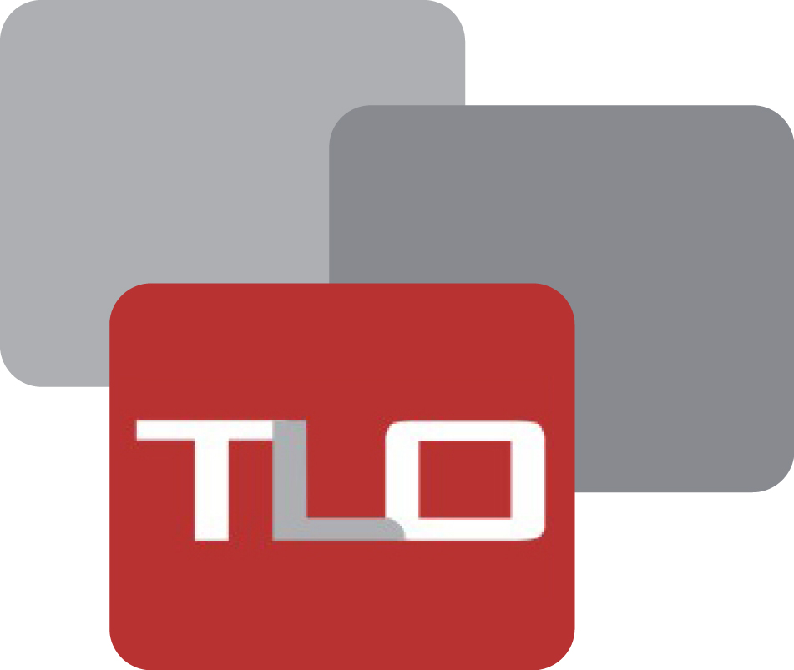

**RFQ No: RFQ-09-2024**

**Request for Quotations (RFQ)**

**(Environmental Radio Drama Series)**

**Project Title: HBS**

**Issue on: 3rd June 2024**

**Closing on: 13th June 2024 (Time: 10:00 am)**

**Introduction:**

**The Liaison Office (TLO)**

The Liaison Office (TLO) is an independent Afghan non-governmental organization established in 2003 and seeking to improve local governance, stability, and security through systematic and institutionalized engagement with customary structures, local communities, and civil society groups. TLO’s main areas of activity are Research/Analysis using the do-no-harm approach; Dialogue Facilitation/Peacebuilding; Access to Justice; and livelihood improvement. In addition to the TLO headquarters in Kabul, the organization has a regional office in Paktia-Southeast, a provincial office in Khost, and multiple project offices across Afghanistan, with over 117 staff. Current and recent TLO funders include the United States Institute of Peace, USAID, the Open Society Institute, DAI (including projects contracted from USAID), and GIZ, along with the governments of Australia (AusAid), Germany, the Netherlands, Norway, Switzerland (SDC), Canada, UNHCR, Cordaid, UNICEF, SIDA and ECW.

**Activities/ Tasks:**

**Term of Reference (ToR)**

**Overview:**

We announce the opportunity for production companies to apply for the creation of a comprehensive series of short environmental radio dramas. This initiative aims to promote good environmental practices and spread awareness on critical environmental topics across Afghanistan. The project involves producing and broadcasting 10 episodes in both Dari and Pashto languages, making it 20 episodes overall. Each episode will be 7 minutes long and broadcasted through radio in the following 10 provinces: Kabul, Kandahar, Nangarhar, Herat, Khost, Nimroz, Ghazni, Balkh, Baghlan, and Kunduz.

**Episode Details:**

* **Number of Episodes:** 10 episodes in Dari and 10 episodes in Pashto, totaling 20 episodes.
* **Duration:** Each episode will be 7 minutes long.
* **Broadcasting time:** Primetime with most listeners
* **Content:** Episodes will feature unique storylines, male and female characters, as well as children to portray an actual image of society.
* **Languages:** Dari and Pashto.
* **Broadcast Provinces:** Kabul, Kandahar, Nangarhar, Herat, Khost, Nimroz, Ghazni, Balkh, Baghlan, and Kunduz.

**Requirements:**

* **Production Timeline:** 1 month to complete the production.
* **Broadcast Timeline:** Following the production month, episodes will be broadcast during the next months. Each week, 4 episodes (2 Dari, and 2 Pashto) will be broadcasted for 5 weeks.
* **Content Style:** Written in a simple, understandable manner considering the current cultural context of the country.
* **Scriptwriting:** The script for each episode should be written by a professional script writer with good knowledge of the environment and cultural context of the country.
* **Diverse Characters:** Include both male and female characters, and children to reflect societal dynamics.
* **Review process: The written script and prepared** materials should be shared with TLO and should get the approval from relevant committee for further process and broadcasting.
* **Produced materials:** All produced materials should be shared with TLO for future use.

**Episode Topics:**

|  |  |  |  |
| --- | --- | --- | --- |
| **Episode** | **Topic** | **Storyline** | **Key Message** |
| 1 | Water Conservation | Follows a family in a rural village struggling with water scarcity and their efforts to conserve water through rainwater harvesting and efficient usage. | Importance of conserving water resources for current and future generations. |
| 2 | Waste Management | Focuses on a community dealing with waste disposal issues and explores the benefits of recycling, composting, and proper waste segregation. | The impact of waste mismanagement on the environment and the need for responsible waste disposal practices. |
| 3 | Deforestation and Reforestation | Centers around a group of villagers witnessing the consequences of deforestation and their initiatives to plant trees and restore the ecosystem. | Highlighting the importance of forests in combating climate change and the role of reforestation in restoring ecological balance. |
| 4 | Renewable Energy | Follows a community's journey in adopting renewable energy solutions like solar panels and cooker to reduce dependence on fossil fuels. | Encouraging the transition to clean and sustainable energy sources to mitigate climate change. |
| 5 | Air Pollution | Explores the health impacts of air pollution on a family living in a polluted city and their efforts to reduce indoor and outdoor air pollution. | Importance of reducing air pollution through cleaner energy sources and lifestyle changes. |
| 6 | Sustainable Agriculture | Follows a farmer implementing sustainable farming practices such as crop rotation, organic fertilizers, and water-efficient irrigation methods. | Promoting sustainable agriculture to protect soil health, conserve water, and reduce environmental impact. |
| 7 | Biodiversity Conservation | Chronicles the efforts of a group of conservationists in protecting endangered species and preserving biodiversity in their region. | Emphasizing the significance of biodiversity conservation for ecosystem stability and human well-being. |
| 8 | Climate Change Adaptation | Depicts a community's adaptation strategies to cope with the impacts of climate change, such as droughts, floods, and extreme weather events. | The importance of resilience and adaptation measures in the face of climate change-induced challenges. |
| 9 | Reducing Plastic Pollution at Home | Follows a family's journey in reducing plastic pollution in their household by adopting practices such as using reusable bags, bottles, and containers. | Highlighting the detrimental effects of plastic pollution on the environment and human health, and empowering individuals to minimize their plastic footprint. |
| 10 | Environmental Advocacy and Community Action | Showcases the power of collective action as community members come together to address environmental issues, advocate for policy change, and promote sustainable living. | Empowering individuals and communities to take action for a healthier environment and a sustainable future. |

**Application Details:**

Interested production companies are invited to submit their proposals detailing their experience in producing educational and cultural content, particularly in radio drama. Proposals should include:

* Company profile and relevant experience.
* Approach to scriptwriting and production.
* Examples of previous work.
* Detailed production timeline.
* Budget estimate.

Please submit your applications by 13th June 2024.

**Eligibility, Evaluation, and Requests for Information**

Only those companies that: (1) possess a valid business license; (2) Have similar project past performance within the last three years. For their bids to be considered “responsive” and be evaluated for award, qualified Offers must:

1. Submit all information required below on or before the time/date mentioned.
2. Demonstrate the capability (supported by client references and/or literature) to meet the requirements specified in the Statement of Work.

**Content and Format of Your Proposal**

For TLO to conduct the most efficient analysis of proposals received, please format your response as follows:

1. A letter of transmittal confirming a. Your company’s status as a licensed firm with AISA/Ministry of Commerce. b. Your company’s commitment to providing good quality items mentioned above to the address mentioned below. c. The validity of your proposal/Quotes for a minimum of Ninety (90) calendar days. The letter must be signed by a person authorized to bind your company and negotiate on your company’s behalf.
2. A discussion of your approach to providing the required services. You must meet ALL the requirements.
3. A description of your company’s capabilities to provide the required services, including evidence of financial responsibility and other Governmental Regulatory licenses.
4. The successful offer will receive a fixed-price contract for the period stipulated in this RFP. The fixed prices will remain in effect for the entire Period of Performance unless modified in writing by TLO.

Rates should be presented in **AFN.**

**TIME FRAME**

The purpose of this RFQ is to identify and hire a vendor to provide the above-listed services.

**Service / Product Delivery and Payment Terms**:

* **Payment method:** The supplier will be paid through a bank Account/Cheque after satisfactory class repair and complete the work according to the RFQ for Herat province and technical confirmation by the related department. (no advance payment to the vendors)
* **Delivery timeline:** ASAP (please mention the delivery date in your quotation)
* **Mode of Shipment:** N/A
* **Head Office Address:** House # 38, Street # 06, Taimani Watt Kabul-Afghanistan and Contact number +93 (0) 700009070.

**Submission of Quotation:**

The deadline for submission of sealed hard copies of offers is 13th June 2024/ 10:00 AM Local Time. (Kabul, Afghanistan time) at the address: House # 38, Street # 06, Taimani Watt Kabul-Afghanistan. Please reference this **(TLO-RFQ-09-2024)** on the sealed envelopes.

Proposals received after the deadline may not be considered. Proposals must be valid for a minimum of Ninety (90) calendar days.

**Questions and Clarifications**

Any questions/clarifications should be submitted by email to **Yama Aman** ([yama.aman@tlo-afghanistan.org](mailto:yama.aman@tlo-afghanistan.org)) & Shoaib Sadaat ([Shoaib.sadaat@tlo-afghanistan.org](mailto:Shoaib.sadaat@tlo-afghanistan.org)) by 2:00 pm (Kabul, Afghanistan time) on June 12th, 2024.

**Prices & Terms of Contract:**

Vendors must quote the price in **AFN**. The price quotes shall be free of any tax (such as VAT)

1. The Liaison Office shall deduct the applicable tax **(currently 2%)** on any contract as required by Afghan Law and will make the direct deposit to the Da Afghanistan Bank if the supplier cannot provide the registration certificate or the registered certificate is against to their business. If still awarded for the contract in this case (**7% tax)** will be deducted from the total amount of the contract and will be deposited to the Da Afghanistan Bank. As the tax withholding entity, The Liaison Office is required to remit the income tax amount withheld directly to the Ministry of Finance designated account.
2. Your quotation will be accepted, and payment will be proceeding as per your business title.
3. The Liaison Office pays for any kind of supply and service; Account payee checks by the name of your company, not by the name of the person (this is not an open check).
4. The penalty applies to the selected company in case of late delivery.
5. You should have a Bank account according to your business title.
6. Your quotation should be signed and stamped.
7. The Liaison Office reserves the right to cancel this process without further notice to the vendors.

**Please Mark:**

1. **I certify that I’ve provided a quote and agree with your payment terms and conditions.**
2. **Total Completion calendar days ( ).**

Signature and or stamp:

…………………………………………………………………………………………………………………………………………

Name: ________________________________________

Company Name: ________________________________________

E-mail address: ________________________________________

Mobile Phone: ________________________________________

Address: ________________________________________