**INVITATION TO TENDER**

**Afghanistan**

**13 May 2024**

**ITT-AFG-NGR-2024-PR462306**

**Construction**

One time setup and rehabilitation of the Static HF at Nangarhar under ECHO

**SUBMISSION DEADLINE :08:00 Am-04:00 Pm, 23 May 2024**

**PRE-SUBMISSION CLARIFICATION MEETING : N/A**

**QUESTIONS / CLARIFICATIONS :** [**AFG.Tenders@savethechildren.org**](mailto:AFG.Tenders@savethechildren.org)

**FORMAT FOR SUBMISSION :** **BIDDER RESPONSE DOCUMENT**

**PART** **1 : INVITATION TO TENDER**

* + Introduction to SCI
  + Project Overview and Requirements
  + Award Criteria
  + Instructions & Key Information

**PART 2 : CORE REQUIREMENTS AND SPECIFICATION**

Detailed description of SCI’s specific requirements (e.g. volumes, delivery dates / locations, product specifications etc).

**PART 3 : BIDDER RESPONSE DOCUMENT**

Template to be used to submit response to this Invitation to Tender.

# **PART 1 – INVITATION TO TENDER**

## **INTRODUCTION TO SAVE THE CHILDREN**

SCI is the world’s leading independent organisation for children. We save children’s lives; we fight for their rights; we help them fulfil their potential. We work together, with our partners, to inspire breakthroughs in the way the world treats children and to achieve immediate and lasting change in their lives.

**Our Vision** – a world in which every child attains the right to survival, protection, development and participation.

**Our Mission** – to inspire breakthroughs in the way the world treats children and to achieve immediate and lasting change in their lives.

We do this through a range of initiatives and programmes, to:

* Provide lifesaving supplies & emotional support for children caught up in disasters (e.g. floods, famine & wars).
* Campaign for long term change to improve children’s lives.
* Improve children’s access to the food and healthcare they need to survive.
* Secure a good quality education for the children who need it most.
* Protect the world’s most vulnerable children, including those separated from their families because of war, natural disasters, extreme poverty or exploitation.
* Work with families to help them out of the poverty cycle so they can feed and support their children.

For more information on the work we undertake and recent achievements, visit our [website](http://www.savethechildren.net/).

## **PROJECT OVERVIEW**

|  |  |
| --- | --- |
| **Item** | **Description** |
| **Description of Goods / Services** | *Provision of Construction Materials / Services – specifically One time setup and rehabilitation of the Static HF at Nangarhar under ECHO* |
| **Outcome of Tender** | ***Contract*** *– the successful supplier(s) will be awarded a ‘Contract’ which will commit SCI to purchase the specified quantity of goods / services as defined in the contract at the agreed rates.* |
| **Duration of Award** | *For the duration of the specific build requirement.* |

Further detail on the specific requirements of the project (e.g. volumes, dates, specifications etc.) can be found in Part 2 (Core Requirements & Specifications) of this Tender Pack.

## **AWARD CRITERA**

SCI is committed to running a fair and transparent tender process, and ensuring that all bidders are treated and assessed equally during this tender process. Bidder responses will be evaluated against three weighted categories of criteria: Essential Criteria, Capability Criteria, and Commercial Criteria.

### **3.1 ESSENTIAL CRITERIA**

Criteria which bidders **must** meet in order to progress to the next round of evaluation. If a bidder does not meet any of the Essential Criteria, they will be excluded from the tender process immediately. These criteria are scored as ‘Pass’ / ‘Fail’.

**3.2 SUSTAINABILITY CRITERIA (10%)**

Criteria used to evaluate the impact a supplier has on the environment, local economy and community. Bids will be evaluated against the same pre-agreed Criteria.

### **3.3 CAPABILITY CRITERIA (40%)**

Criteria used to evaluate the bidders ability, skill and experience in relation to the requirements. Bids will be evaluated against the same pre-agreed Criteria.

### **3.4 COMMERIAL CRITERIA (50%)**

Criteria used to evaluate the commercial competitiveness of a bid. Bids will be evaluated against the same pre-agreed Criteria.

## **VETTING**

Successful bidders must be successfully vetted. This involves checking bidders and key personnel against Global Watch Lists, Enhanced Due Diligence Lists and Politically Exposed Persons Lists.

The vetting of bidders will be completed after the award decision and prior to any contract being signed, or orders placed. If any information provided by the Bidder throughout the tender process is proved to be incorrect during the vetting process (or at any other point), SCI may withdraw their award decision.

## **BIDDER INSTRUCTIONS**

### **6.1 TIMESCALES**

|  |  |
| --- | --- |
| Activity | Date |
| Issue Invitation to Tender | 13 May 2024 |
| Pre-Submission Clarification Meeting | N/A |
| Deadline for questions from Bidders | 20 May 2024 |
| Deadline for Bid Submission | 23 May 2024 |
| Bid Clarifications | 28 May 2024 |
| Award Contact | 30 June 2024 |

The above dates are for indicative purposes only and are subject to change. However, SCI commits to ensure all Bidders receive notification of changes to timescales in a fair and transparent manner.

### **6.2 SUBMISSION FORMAT & BIDDER RESPONSE DOCUMENT**

Bidders wishing to submit a bid **must use the Bidder Response Document template in** **Part 3** **of this Tender Pack**. Any bids received using different formats, or incomplete bids, will not be accepted.

This document allows bidders to submit all the required information and be evaluated fairly and equally against the Essential, Capability and Commercial Criteria. In addition to the Bidder Response Document, bidders may also be required to submit supporting documentation. Instructions on how to do this, and how to complete the Bidder Response Document can be found within the document in Part 3 of this pack.

Bids can be submitted by either:

**Electronic Submission via ProSave**

* Submit your response in accordance with the guidance provided in the below document:



**Electronic Submission via Email**

* Email should be addressed to Save the children at [**AFG.Tenders@savethechildren.org**](mailto:AFG.Tenders@savethechildren.org)
* Note – this is a sealed tender box which will not be opened until the tender has closed. Therefore, do not send tender related questions to this email address as they will not be answered.
* The subject of the email should be **“ITT AFG- NGR-2024- PR462306** Bidder Response – ‘Bidder Name’, ‘Date’’.
* All attached documents should be clearly labelled so it is clear to understand what each file relates to.
* Emails should not exceed 15mb – if the file sizes are large, please split the submission into two emails.
* Do not copy other SCI email addresses into the email when you submit it as this will invalidate your bid.

**Paper Submission**

* Two paper copies submitted on headed paper to Save the Children International Behind Mia Omer high school, Angoor Bagh in front of the Public Park District#2 Nangarhar, Afghanistan
* Bids should be submitted in a single sealed envelope addressed to SCI-Afghanistan Supply Chain The envelope should clearly indicate the Invitation to tender reference number **ITT-AFG- NGR-2024- PR462306**, but contain no other details relating to the bid or the bidder name.
* All supporting documentation should be labelled and grouped together (individual envelopes, stapled etc), and then included in a single sealed envelope as per the above.

### **6.4 CLOSING DATE FOR BID SUBMISSION**

Your bid must be received, no later than **23 May 2024 at or before 4:00 PM**

Bids must remain valid and open for consideration for a period of no less than 60 days.

### **6.5 KEY CONTACTS**

All questions relating to the tender should be sent via email to:

|  |  |
| --- | --- |
| Name | Email Address |
| SCI-Afghanistan Supply Chain | [**AFG.Tenders@savethechildren.org**](mailto:AFG.Tenders@savethechildren.org) |

Please be advised local working hours are **08:00 AM – 04:00 PM** Please allow up to Sunday to Thursday days for a response.

Where the enquiry may have an impact on other bidders within the process, Save the Children will notify all other Bidders to maintain a fair and transparent process.

# **PART 2 – CORE REQUIREMENTS & SPECIFICATIONS**

1. **SPECIFIC REQUIREMENTS**

* **Description-One time setup and rehabilitation of the Static HF at Nangarhar under ECHO**
* **Location -SADA KAS SHIRZAD-SURKH DEWAL -SORKHAB ACHIN**
* **Required Date -29 August 2024**

1. **SPECIFICATIONS**

**Construction of one-time setup and rehabilitation of the Static HF at Nangarhar under ECHO**

* **According to the BOQ and Drawing in the targeted places i.e. Location -SADA KAS SHIRZAD-SURKH DEWAL -SORKHAB ACHIN – The BOQ and technical Drawings are provided in Section 3 Commercial Part**

1. **ADDITIONAL INFORMATION**

**N/A**

1. **WAYS OF WORKING**
   1. **Site safety protocol & Security** 
      1. Save the Children expects all suppliers to ensure protection of site, staff and visitors (including community and children) during the time of construction
      2. Suppliers should ensure that premises are made secure with security personnel in place to monitor access and keep a record of visitors accessing the premises
      3. Suppliers should provide appropriate Protective Personnel Equipment for all labourers
      4. Controlled access should be implemented at the site of construction
      5. Save the Children expects the successful supplier to provide latrine facilities for labourers which should be segregated by gender, but this is not mandated.
      6. Save the Children expects the successful supplier to provide all appropriate signage required for the project including but not limited to warning of danger, no unauthorised access etc.
   2. **Staff** 
      1. Depending on the nature of construction project, Save the Children consider the following core roles for the delivery of a successful project.   
          1. Site Agent  
          2. Site Foreman  
          3. Any other skilled personnel as required for the project e.g. Carpenter, stabilised soil block expert, safety agent.All proposed staff for core roles should be fully qualified as per the Country requirements e.g. Bachelor degree in Civil Engineering, Foremanship certificate etc.
      2. Suppliers should provide a full and signed Curriculum Vitae (CV) for the above core roles. The personnel performing core roles must be able to read and interpret all technical documents written in the national speaking language
      3. *For minor construction projects:* Save the Children accept that the Supplier may propose resources that combine the site agent / foremen roles as well as any additional skilled personnel as long as long as training, skills and experience required to complete the work can be demonstrated
   3. **Site Visits**Constructor should provide evidence as part of supplier response to confirm that they have visited the proposed site and appropriately budgeted and planned for all additional requirements (including time)
   4. **Workplan**
      1. Supplier is expected to provide a detailed workplan which includes mobilization and temporary works, e.g., site hoarding, scaffold and signage, inspection dates, milestones for payment and quality processes.
      2. Suppliers are encouraged to indicate timelines for quality procedures e.g. curing of concrete
      3. Workplans should also include milestones for inspection e.g. steel re-enforcing and form work before casting concrete
      4. The work plan should be included in the Bidder Response Document.
      5. An example workplan layout is below, suppliers should use a similar format.

|  |  |  |  |  |  |  |  |  |  |  |  |  |  |  |  |
| --- | --- | --- | --- | --- | --- | --- | --- | --- | --- | --- | --- | --- | --- | --- | --- |
| **NO** | **WORK ITEM** | | **DURATION**  **(Days)** | **MONTH 1** | | | | **MONTH 2** | | | | **MONTH 3** | | | |
| **W1** | **W2** | **W3** | **W4** | **W1** | **W2** | **W3** | **W4** | **W1** | **W2** | **W3** | **W4** |
| **1** | | **Preliminaries** |  |  |  |  |  |  |  |  |  |  |  |  |  |
| **2** | **Temporary structures** | |  |  |  |  |  |  |  |  |  |  |  |  |  |
| **3** | **Mobilisation** | |  |  |  |  |  |  |  |  |  |  |  |  |  |
| **4** | **Sub structures** | |  |  |  |  |  |  |  |  |  |  |  |  |  |
| **5** | **Superstructure** | |  |  |  |  |  |  |  |  |  |  |  |  |  |
| **6** | **Roof** | |  |  |  |  |  |  |  |  |  |  |  |  |  |
| **7** | **Finishing** | |  |  |  |  |  |  |  |  |  |  |  |  |  |
| **8** | **Handover / completion date** | |  |  |  |  |  |  |  |  |  |  |  |  |  |

* 1. **Method Statement**
     1. It is expected that suppliers should provide a Method Statement as part of the their response and should as minimum include the following content:   
        - Brief description of the works, task or process  
        - Start and completion dates  
        - Site contact details including an in an emergency contact  
        - Summary of known hazards and control measures to mitigate  
        - Personal protective equipment (PPE) that is mandated for labourers to wear for the duration of the project  
        - Applicable environmental or quality procedures  
        - Statement of actions that must be taken to ensure the tasks can be performed safely  
        - Total lead time  
        - Mobilization and procurement / sourcing or materials. In particular provide information about supplier selection, transportation requirements and recognition of site specific constraints to be overcome e.g. rocky ground).
     2. Method statement for site safety protocol should include as minimum:
        1. Protection of site, staff and visitors
        2. Health and safety on site
        3. Signage
        4. Traffic calming
  2. Incident reporting.  
       
     **Drawings, Bill of Quantities and Specifications**
     1. Suppliers should familiarise themselves with all the documentation (drawings and bill of quantities (BOQ) for the works) provided to ensure their priced bid is in accordance with the designs, BOQ and specifications

# **PART 3 – BIDDER RESPONSE DOCUMENT**

1. **INTRODUCTION**

This document **MUST BE USED** by Bidders wishing to submit a bid. It is linked into 5 sections detailed below:

* Section 1 – Essential Criteria
* Section 2 – Capability & Sustainability Questions
* Section 3 – Commercial Questions
* Section 4 – Bidder Submission Checklist
* Schedule 1 – Terms & Conditions of Bidding

**The Bidder is required to sign a copy of the Check list in Section 4 as part of their submission**.

1. **INSTRUCTIONS**

Within each section there are instructions providing guidance to the bidder on what information is required. This guidance details the **MINIMUM** requirements expected by SCI. If a Bidder wishes to add further information, this is acceptable but the additional information should be limited to only items that are relevant to the tender.

* For the avoidance of doubt, bidders are required to complete all items within the Bidder Response Document unless clear instruction is provided otherwise.
* If a Bidder does not complete the entire Bidder Response document, their submission may be declared void.
* If a Bidder is unable to complete any element of the Bidder Response Document, they should contact Save the Children through the using the contact details provided for guidance.

By submitting a response, the bidder confirms that all information provided can be relied upon for validity and accuracy.

## **SECTION 1 - ESSENTIAL CRITERIA**

|  |  |  |  |
| --- | --- | --- | --- |
| ***Item*** | **Question** | **Bidder Response** | |
| ***1*** | ***The Supplier and its staff (and any sub-contractors used) agree to comply with SCI and the IAPG’s policies and code of conducts listed below.***  ***1) Child Safeguarding Policy***  ***2) Anti-Bribery & Corruption Policy***  ***3) Human Trafficking & Modern Slavery Policy***  ***4) Protection from Sexual Exploitation and Abuse Policy***  ***5) Anti-Harassment, Intimidation & Bullying Policy***  ***6) IAPG Code of Conduct***  ***7) Conditions of Tendering***  ***8)sustainability*** | **Yes / No** | **Comments** |
|  |  |
| ***2*** | ***The Supplier confirms it is not linked directly or indirectly to any terrorism related activity and does not sell any Dual-Purpose goods / services that may be used in a terror related activity.*** | **Yes / No** | **Comments** |
|  |  |
| ***3*** | ***The Supplier confirms it is fully qualified, licenses and registered to trade with Save the Children (including compliance with all relevant in Afghanistan Country legislation).***  ***This includes the Supplier submitting the following requirements (where applicable):***  ***Business registration certificate in Afghanistan***  ***Bank Account by the name of company/by owner*** | **Yes / No** | **Comments** |
|  |  |
| **Document** | **Evidence Attached** |
|  |  |
| ***4*** | ***Only Construction Companies are eligible to quote for this activity*** | **Yes / No** | **Comments** |
|  |  |

***INSTRUCTIONS – Bidders are required to complete all sections of the below table.***

## **SECTION 2 – CAPABILITY QUESTIONS**

***Instructions – Bidders are required to complete all sections of the below table.***

|  |  |  |  |
| --- | --- | --- | --- |
| ***Item*** | **Score** | **Question** | **Bidder Response** |
| ***1*** | ***10%*** | **Experience**  ***Provide at least 2 copies of relevant one for bore wells and one for construction, or relevant (percussion drilling) construction of any type of contract along with references with UN, Government, national and international NGOs. the***  ***5 Marks for each contract and***  ***Zero marks for no contract provided.***  ***The suppliers are allowed to remove the confidential parts of the Contract while they are providing the contracts copies.*** |  |
| ***2*** | ***10 %*** | **Lead Times**  ***Less than 50 calendar days lead time will get 10 marks, from 51 up to 70 days will get 5 and above 71 days will get zero marks.***  ***Please provide the work plan to justify the days for each location to cover the lead time. Marks will be provided based on logical work plan to justify the lead time.***  ***Note: The lead time will be part of the Contract, and if not met will be subjected to penalty as stipulated in the contract as per day rate. Penalty (0.02)*** |  |
| ***3*** | ***6%*** | **Financial Check**  ***Provide one year bank statement for financial turn over review of the supplier years 2021 up to 2024 provide documents to show the financial capacity of the company.***  ***Each year will get 1.5 points.***  ***No provide statement will get zero.*** |  |
| ***4*** | ***10%*** | ***Supplier to provide written confirmation for accepting below payment schedule (Payment Milestone)***  ***Bidder to accept below payment schedule in bidder response.***  ***If supplier completed tow bore well SCI will pay for 1 bore well if the supplier completes 3 bore well sci will pay for 2***  ***If supplier completed the two static facility construction SCI will pay for one static health care facility the remaining will be pay after completion of 3 static health facility***  ***After completion of all work SCI will pay 90 %Percent amount and 10 % will be remain as retention payment it will be pay after 3 months.***  ***If any bore well remain uncomplete SCI will not pay amount of that bore well.*** |  |
| ***5*** | ***4%*** | **Quote Validity**  ***Provide quote validity for 90 days. Please confirm as yes in the front bidder response box***  ***4 Marks 90 or more days quote validity***  ***Zero marks for less than 90 days quote validity*** |  |

|  |  |  |  |
| --- | --- | --- | --- |
| ***Item*** | **Evaluation Criteria** | **Sustainability Criteria Description**  **(Minimum Weighting is 10%)** | **Bidder Response Question number** |
| ***1*** | 10 % | 10/10 - Bidder uses 100% locally sourced materials  5/10 - Bidder uses some locally sourced materials  0/10 - Bidder does not use any locally sourced materials  Supplier will confirm in comment box. |  |

**SECTION 3 – COMMERCIAL QUESTIONS**

|  |  |
| --- | --- |
| **PRICING SUBMISSION** | |
| **<<CO to insert detail on how pricing is to be submitted (e.g. in BOQ or WorkPlan document)** | |
| **OTHER COMMERCIAL CONSIDERATIONS** | |
| **Duration for which pricing can be fixed** | For the whole duration of the contract |

# **(SADA KAS SHERZAD)**

# **Rehabilitation of Static Health Facility including Concrete Flooring**

|  |  |  |  |  |  |  |
| --- | --- | --- | --- | --- | --- | --- |
| **Item** | **Items Description** | **Size/ Specification** | **Unit** | **Qty** | **Unit cost USD** | **Total USD** |
| 1 | Site preparation | Site preparation and leveling (25 m x 27 m). | Lum sum | 1 |  |  |
| 2 | Excavations | Excavation for the foundation Connex and walkway. Excavations for the fence columns as per the drawings | m3 | 760 |  |  |
| 3 | Boulder stone | boulder stone for the foundation of the Connex and walkway as per the drawings | m3 | 59 |  |  |
| 4 | PCC (M15) | PCC (M15) for the walkway, foundation of the Connex as per drawings and floors of the Tents. PCC (15) for the fence columns as per the drawings | m3 | 67 |  |  |
| 5 | Shadow | construction of the two shadows (1.5 m x 1.5) including concrete and steel columns for the drinking water points. 24 Gauge Metal Sheet. | No | 2 |  |  |
| 6 | Precast chair | precast chair for the waiting purpose as per the drawings. Concrete Chairs Reinforced Normal, backrest Off White color Size 205 × 50 cm, Height: 70 cm, made of weather-resistant cement, it can withstand cold, heat, snow and rain. This makes it the perfect choice for gardens, and other open spaces. | No | 4 |  |  |
| 7 | GI pipe 2.5 inch, thickness= 2.5mm for Fence | GI pipe 2.5 inch, thickness= 2.5mm for the columns of the surrounding fence, each pipe should be 2.9m. | No | 37 |  |  |
| 8 | GI pipe 2.0-inch, thickness= 2.5mm for Fence | GI pipe 2.0-inch, thickness= 2.5mm for the horizontal member of the surrounding fence, each pipe should be 3m. | No | 74 |  |  |
| 9 | Wire Mesh net | Wire Mesh net, the Hight of the Net should be 2m (3mmX25.4mm) | M | 116 |  |  |
| 10 | Shade Cloth (Health Facility Privacy Fence Cover) | Shade Cloth (Health Facility Privacy Fence Cover) with 2 meter height | M | 116 |  |  |
| 11 | Drinking water Cooling and Heating Despenser | Drinking water Cooling and Heating Despenser | No | 2 |  |  |
| 12 | Fire Extinguisher | Fire extinguisher (Wet Chemical, Carbon Dioxide, and ABC powder) | Set of three | 1 |  |  |
| 13 | Alteration of green area (garden) | Leveling and alteration of garden with seating provision/platform, as per the drawings total around 145 square meters area. | No | 2 |  |  |
| 14 | Solid waste management | Solid waste management equipment and medical dustbin and disposal bags. Total 10 Dust Bin with the capacity of 80 Liters with total 10 dozen of plastic waste bags | No | 10 |  |  |
|  | **GRAND TOTAL ESTIMATED COST** | | **USD** | | |  |

# **(Surkh Dewal)**

# **Rehabilitation of Static Health Facility including Concrete Flooring**

|  |  |  |  |  |  |  |
| --- | --- | --- | --- | --- | --- | --- |
| **Item** | **Items Description** | **Size/ Specification** | **Unit** | **Qty** | **Unit cost USD** | **Total USD** |
| 1 | Site preparation | Site preparation and leveling (25 m x 27 m). | Lum sum | 1 |  |  |
| 2 | Excavations | Excavation for the foundation Connex and walkway. Excavations for the fence columns as per the drawings | m3 | 1800 |  |  |
| 3 | Boulder stone | boulder stone for the foundation of the Connex and walkway as per the drawings | m3 | 59 |  |  |
| 4 | PCC (M15) | PCC (M15) for the walkway, foundation of the Connex as per drawings and floors of the Tents. PCC (15) for the fence columns as per the drawings | m3 | 67 |  |  |
| 5 | Shadow | construction of the two shadows (1.5 m x 1.5) including concrete and steel columns for the drinking water points. 24 Gauge Metal Sheet. | No | 2 |  |  |
| 6 | Precast chair | precast chair for the waiting purpose as per the drawings. Concrete Chairs Reinforced Normal, backrest Off White color Size 205 × 50 cm, Height: 70 cm, made of weather-resistant cement, it can withstand cold, heat, snow and rain. This makes it the perfect choice for gardens, and other open spaces. | No | 4 |  |  |
| 7 | GI pipe 2.5-inch, thickness= 2.5mm for Fence | GI pipe 2.5-inch, thickness= 2.5mm for the columns of the surrounding fence, each pipe should be 2.9m. | No | 37 |  |  |
| 8 | GI pipe 2.0-inch, thickness= 2.5mm for Fence | GI pipe 2.0-inch, thickness= 2.5mm for the horizontal member of the surrounding fence, each pipe should be 3m. | No | 74 |  |  |
| 9 | Wire Mesh net | Wire Mesh net, the Hight of the Net should be 2m (3mmX25.4mm) | M | 116 |  |  |
| 10 | Shade Cloth (Health Facility Privacy Fence Cover) | Shade Cloth (Health Facility Privacy Fence Cover) with 2-meter height | M | 116 |  |  |
| 11 | Drinking water Cooling and Heating Despenser | Drinking water Cooling and Heating Despenser | No | 2 |  |  |
| 12 | Fire Extinguisher | Fire extinguisher (Wet Chemical, Carbon Dioxide, and ABC powder) | Set of three | 1 |  |  |
| 13 | Alteration of green area (garden) | Leveling and alteration of garden with seating provision/platform, as per the drawings total around 145 square meters area. | No | 2 |  |  |
| 14 | Solid waste management | Solid waste management equipment and medical dustbin and disposal bags. Total 10 Dust Bin with the capacity of 80 Liters with total 10 dozen of plastic waste bags | No | 10 |  |  |
|  | **GRAND TOTAL ESTIMATED COST** | | **USD** | | | **-** |

# **(Sorkhab Achin District)**

# **Rehabilitation of Static Health Facility including Concrete Flooring**

|  |  |  |  |  |  |  |
| --- | --- | --- | --- | --- | --- | --- |
| **Item** | **Items Description** | **Size/ Specification** | **Unit** | **Qty** | **Unit cost USD** | **Total USD** |
| 1 | Site preparation | Site preparation and leveling (25 m x 27 m). | Lum sum | 1 |  |  |
| 2 | Excavations | Excavation for the foundation Connex and walkway. Excavations for the fence columns as per the drawings | m3 | 760 |  |  |
| 3 | Retaining wall | Retaining wall for the static facilities | m3 | 75 |  |  |
| 4 | Boulder stone | boulder stone for the foundation of the Connex and walkway as per the drawings | m3 | 59 |  |  |
| 5 | PCC (M15) | PCC (M15) for the walkway, foundation of the Connex as per drawings and floors of the Tents. PCC (15) for the fence columns as per the drawings | m3 | 67 |  |  |
| 6 | Shadow | construction of the two shadows (1.5 m x 1.5) including concrete and steel columns for the drinking water points. 24 Gauge Metal Sheet. | No | 2 |  |  |
| 7 | Precast chair | precast chair for the waiting purpose as per the drawings. Concrete Chairs Reinforced Normal, backrest Off White color Size 205 × 50 cm, Height: 70 cm, made of weather-resistant cement, it can withstand cold, heat, snow and rain. This makes it the perfect choice for gardens, and other open spaces. | No | 4 |  |  |
| 8 | GI pipe 2.5 inch, thickness= 2.5mm for Fence | GI pipe 2.5 inch, thickness= 2.5mm for the columns of the surrounding fence, each pipe should be 2.9m. | No | 37 |  |  |
| 9 | GI pipe 2.0-inch, thickness= 2.5mm for Fence | GI pipe 2.0-inch, thickness= 2.5mm for the horizontal member of the surrounding fence, each pipe should be 3m. | No | 74 |  |  |
| 10 | Wire Mesh net | Wire Mesh net, the Hight of the Net should be 2m (3mmX25.4mm) | M | 116 |  |  |
| 11 | Shade Cloth (Health Facility Privacy Fence Cover) | Shade Cloth (Health Facility Privacy Fence Cover) with 2 meter height | M | 116 |  |  |
| 12 | Drinking water Cooling and Heating Despenser | Drinking water Cooling and Heating Despenser | No | 2 |  |  |
| 13 | Fire Extinguisher | Fire extinguisher (Wet Chemical, Carbon Dioxide, and ABC powder) | Set of three | 1 |  |  |
| 14 | Alteration of green area (garden) | Leveling and alteration of garden with seating provision/platform, as per the drawings total around 145 square meters area. | No | 2 |  |  |
| 15 | Solid waste management | Solid waste management equipment and medical dustbin and disposal bags. Total 10 Dust Bin with the capacity of 80 Liters with total 10 dozen of plastic waste bags | No | 10 |  |  |
|  | **GRAND TOTAL ESTIMATED COST** | | **USD** | | | **-** |

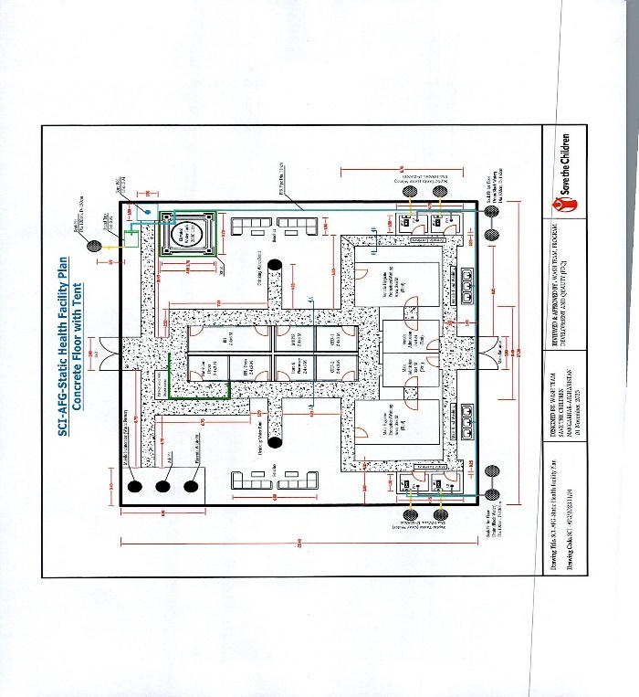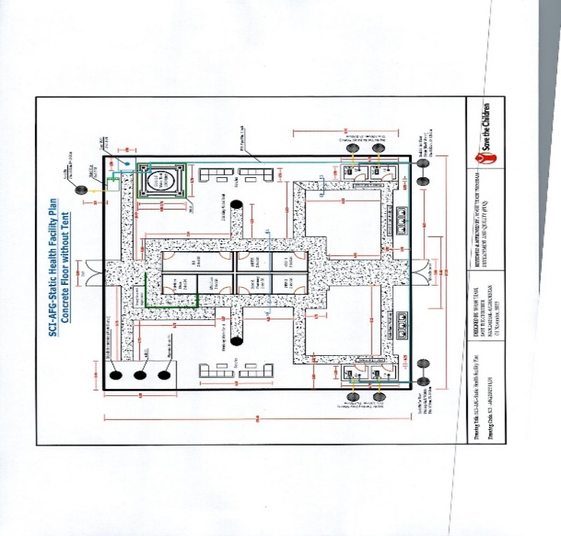

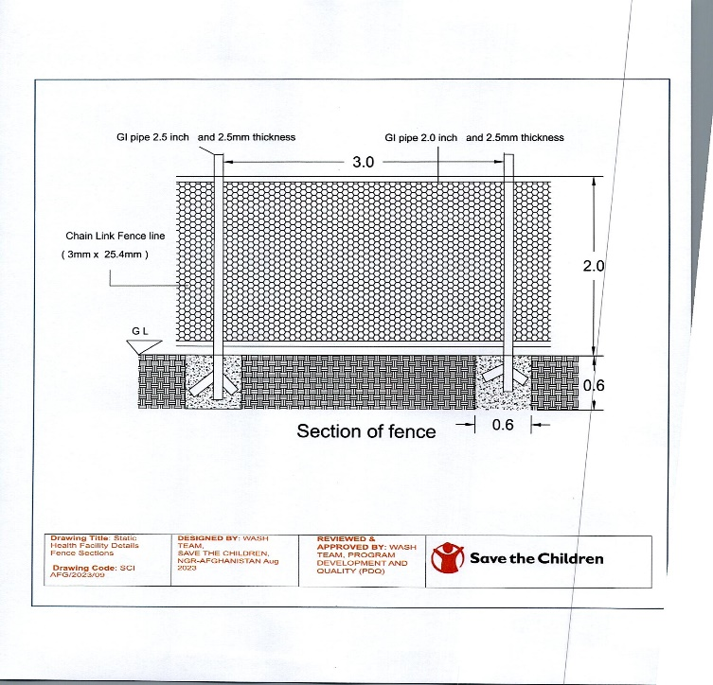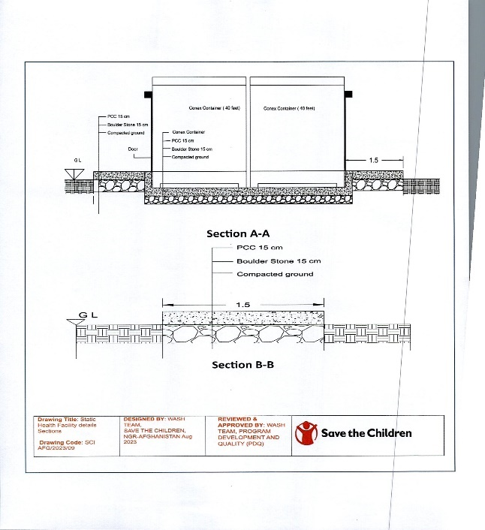

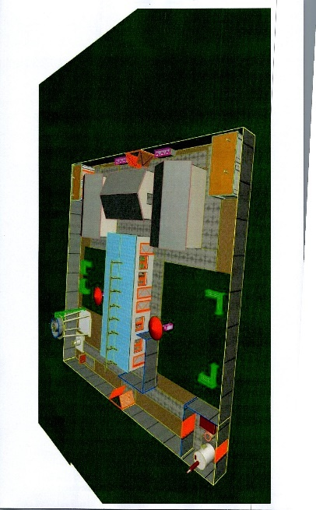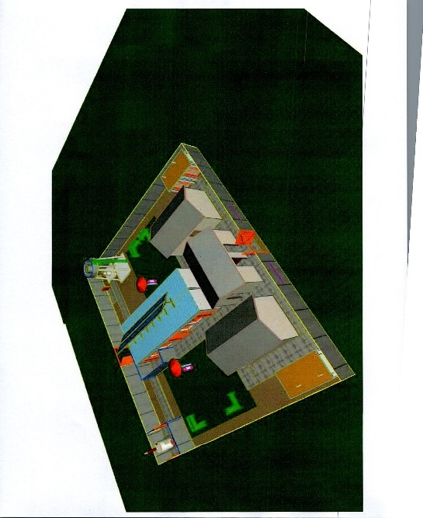

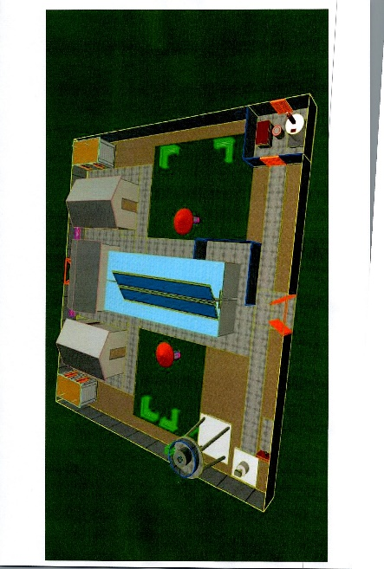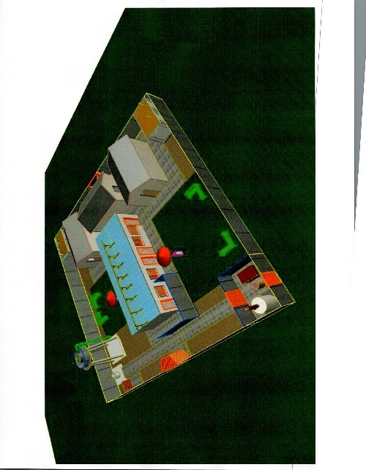

# **Ashpit (SADA KAS SHIRZAD)**

|  |  |  |  |  |  |  |
| --- | --- | --- | --- | --- | --- | --- |
| **Construction of metallic drum Burner** | | | | | | |
| **SNO** | **Item** | **Description** | **Unit** | **Quantity** | **Unit cost USD** | **Sub-total price USD** |
| **1** | **Mobile Burner made of GI sheet thickness 1.5mm** | **Mobile Burner – specification should be: Cylindrical in shape as it must have 90cm of height, 58 to 60 cm diameter or its pyramid or outer girth should be 182 – 188 cm. it must be made of galvanized iron sheet 1.5mm. there should be iron pipe for ventilation of smoke - diameter 3 inches and height 2 meters, Installation of iron mash/net 10 mm thickness and 50mm mash, with three doors (one on the top, two at side and as per the drawings and engineering input). Supplier also needed to provide two iron box 40 x80 mm with length of 2m along the incinerator. All the welding should take place properly as per the drawing and WASH engineering input.** | **Piece** | **1** |  |  |
| **2** | **Digging pitches** | **Pitches with depth of 2m and 1.1 - 1.2 m of diameter** | **m3** | **2.5** |  |  |
| **3** | **PCC on top of ring and 2 by 2m** | **PCC on top of the rings having frame of 2 by 2** | **m3** | **0.5** |  |  |
| **4** | **RCC Rings** | **concrete rings having inner diameter of 80cm, outer diameter of 90cm, height of 40cm, thickness of 5cm and having three layers of steel bars with diameter of 6mm** | **Piece** | **5** |  |  |
|  |  |  |  |  | **TOTAL** |  |

# **Ashpit (Sork Dewal)**

|  |  |  |  |  |  |  |
| --- | --- | --- | --- | --- | --- | --- |
| **Construction of metallic drum Burner** | | | | | | |
| **SNO** | **Item** | **Description** | **Unit** | **Quantity** | **Unit cost USD** | **Sub-total price USD** |
| **1** | **Mobile Burner made of GI sheet thickness 1.5mm** | **Mobile Burner – specification should be: Cylindrical in shape as it must have 90cm of height, 58 to 60 cm diameter or its pyramid or outer girth should be 182 – 188 cm. it must be made of galvanized iron sheet 1.5mm. there should be iron pipe for ventilation of smoke - diameter 3 inches and height 2 meters, Installation of iron mash/net 10 mm thickness and 50mm mash, with three doors (one on the top, two at side and as per the drawings and engineering input). Supplier also needed to provide two iron box 40 x80 mm with length of 2m along the incinerator. All the welding should take place properly as per the drawing and WASH engineering input.** | **Piece** | **1** |  |  |
| **2** | **Digging pitches** | **Pitches with depth of 2m and 1.1 - 1.2 m of diameter** | **m3** | **2.5** |  |  |
| **3** | **PCC on top of ring and 2 by 2m** | **PCC on top of the rings having frame of 2 by 2** | **m3** | **0.5** |  |  |
| **4** | **RCC Rings** | **concrete rings having inner diameter of 80cm, outer diameter of 90cm, height of 40cm, thickness of 5cm and having three layers of steel bars with diameter of 6mm** | **Piece** | **5** |  |  |
|  |  |  |  |  | **TOTAL** |  |

**Ashpit (Sorkhab Achin)**

|  |  |  |  |  |  |  |
| --- | --- | --- | --- | --- | --- | --- |
| **Construction of metallic drum Burner** | | | | | | |
| **SNO** | **Item** | **Description** | **Unit** | **Quantity** | **Unit cost USD** | **Sub-total price USD** |
| **1** | **Mobile Burner made of GI sheet thickness 1.5mm** | **Mobile Burner – specification should be: Cylindrical in shape as it must have 90cm of height, 58 to 60 cm diameter or its pyramid or outer girth should be 182 – 188 cm. it must be made of galvanized iron sheet 1.5mm. there should be iron pipe for ventilation of smoke - diameter 3 inches and height 2 meters, Installation of iron mash/net 10 mm thickness and 50mm mash, with three doors (one on the top, two at side and as per the drawings and engineering input). Supplier also needed to provide two iron box 40 x80 mm with length of 2m along the incinerator. All the welding should take place properly as per the drawing and WASH engineering input.** | **Piece** | **1** |  |  |
| **2** | **Digging pitches** | **Pitches with depth of 2m and 1.1 - 1.2 m of diameter** | **m3** | **2.5** |  |  |
| **3** | **PCC on top of ring and 2 by 2m** | **PCC on top of the rings having frame of 2 by 2** | **m3** | **0.5** |  |  |
| **4** | **RCC Rings** | **concrete rings having inner diameter of 80cm, outer diameter of 90cm, height of 40cm, thickness of 5cm and having three layers of steel bars with diameter of 6mm** | **Piece** | **5** |  |  |
|  |  |  |  |  | **TOTAL** |  |

**(SADA KAS SHIRZAD)**

**Solar system Borewell**

|  |  |  |  |  |  |  |
| --- | --- | --- | --- | --- | --- | --- |
| **No** | **Description of work** | **مشخصات فعالیت** | **Unit** | **Quantity** | **Unit Cost (USD)** | **Total Cost (USD)** |
| 1 | Digging of 12" semi deep well with percussion machine depends on soil texture with circulation and filtration water of well after finishing and cleaning of around the well. | کندن کاری چاه به قطر(12) انچ شکل کوبه یی الی سطح زمین نظربه نوعیت خاک وصاف نمودن چاه وپاکاری اطراف چاه. | M | 100 |  |  |
| 2 | Supply and Installation of PVC 6" pipe class -C each 4m length 20kg . The length of the casing should be declared after drill analysis and ground-start. | تهیه ونصب نل پلاستیکی 6 انچ (PVC) کلاس سی اصلی هر خاده ۴ متره دارای 20 کیلو گرام وزن باشد. | M | 70 |  |  |
| 3 | Supply and installation of filter pipe PVC Class-B. 6-inch dia (each 4m length 20kg). The total area for filter pipe openings should not be more than 25% of the total area. Length of filter pipe should be declared after drill analysis and ground-start. Additional filtering should be provided around the filter pipe. | تهیه ونصب نل فلتر پلاستیکی 6 انچ (PVC) کلاس سی اصلی هر خاده آن به طول ۴ متر 20 کیلوگرام باشد. مجموعه ساحه فلتر باید ۲۵ فیصد ساحه مجموعی باشد. نصب فلتر تصفیوی به اطراف پیپ فلتر. | M | 30 |  |  |
| 4 | Pump test for determination of Hydrogeological Parameters. (Pumping Test for 12 hours Including all sub activities according to technical requirements) | پمپ تیست برای معین ساختن پارامتر هایدروجولوژیک. (پمپ تیست برای ۱۲ ساعت بشمول تمام امور ایجابی ) | Hour | 12 |  |  |
| 5 | Water quality Test Biological and (PH, TDS, Turbidity, EC) by the standard laboratory, and Well Chlorination. | آزمایش کیفیت آب آزمایش بیولوژیکی و(PH, TDS, Turbidities) توسط آزمایش گاه معیاری وهم چنان کلوریشن آب چاه بعد ازحفاری. | LS | 1 |  |  |
| 6 | Filling gravel around the filter and casing pipes, to Interval 2-6 mm washed gravel from smooth Sea. | پرکاری اطراف نل کیسنگ و فلتر تصفیوی باجغل اندازه های کوچک شسته شده وصاف باضخامت 2-6 ملی متر. | M3 | 3 |  |  |
| 7 | Working with soft soil, gravel around the casing also around well PCC and Steel 2mm cup 40x40 Hamdard for well hole. | پرکاری اطراف نل کیسنگ باخاک نرم وجغل به اندازه های کوچک شسته شده وصاف هم چنان کانکریت ریزی اطراف دهن چاه وساختن سرپوش فلزی به ضخامت ۲ ملی متر. | Set | 1 |  |  |
| 8 | Water pump1-inch, 1.5-kilowatt, Zyaye only For solar operated well including other needed materials or equivalent best quality acceptable by SCI. | تهیه و نصب واتر پمپ (ضیایی مخصوص سیستم سولر) با امورات ایجابی آن. | Set | 1 |  |  |
| 9 | Solar Panel 545 Watt new with installation. | سولر بانصب وتمام امورات ایجابی آن | Pc | 8 |  |  |
| 10 | Joint box water (Inverter-4/5.5) and Control box horse power one including other relevant items | مولد وکنترول باکس برای تبدیل نمودن برق ۴/۵.۵ هارس پاور | Pc | 1 |  |  |
| 11 | Hard Black pipe 16 bar with installation (1-inch), HDPE pipe | پیپ سیاه سخت (۱۶ بار) رسانده به ساحه ونصب آن | M | 130 |  |  |
| 12 | Supply and installation of Cable, Screw, Glue and other required items. | لین به خاطر پمپ سه فاز رسانده به ساحه ونصب آن | M | 110 |  |  |
| 13 | provide string for casing and water pump 2 inch. | تهیه ریسمان تاری ۲ اینج رسانده به ساحه محکم وجدید. | M | 222 |  |  |
| 14 | metal beam 2-inch Tajiki for using around the pallet of solar | گادر فلزی ۲ انچ ساخت تاجکستان برای اسفتاده اطراف پلیت تخته های سولر. | M | 40 |  |  |
| 15 | Profile (0.5x1) 2 mm original with best quality(3-Coats Oil Painting) | پروفیل اصلی ۰.۵*۱ به ضخامت ۲ ملی متر باکیفت عالی ضدزنگ ورنگ روغنی ۳ قلم . | M | 40 |  |  |
| 16 | Pillar from Zinc pipe 6 inch for solar including other relevant materials standing, concrete (PCC)… | پایه جستی ۶ انچ برای تخته های سولرباتمام مواد لازمی ونصب آن همراه باکانریت بدون سیخ به عمق مناسب. | M | 3 |  |  |
| 17 | Equipment for water network such as (water tap 1 inch, elbow 1-inch, Semitic 1inch, female elbow 1inch, three mouth PVC, phoom large&smal, elbow simple, water tap 3inch, three mouth 3inch…with all necessary) complete work for water point. | اجزای ارتباط دهنده شبکه آبرسانی برای یک نقطه آبگیر باتمام امورات ایجابی آن شیردهن؛ زانو خم ؛ سه دهن ؛ پوم باتمام امورات ایجابی آن مکمل کار. | Set | 1 |  |  |
| 18 | Burned brick work with plastering for one water point (drawing is attached) | خشت کاری بصورت پخته همراه باپلسترکاری برای یک نقطه آبگیر مطابق به (نقشه مهندسی ضمیمه شده است). | M3 | 1 |  |  |
| 19 | Water reservoir with standing and installation, all necessary (according to- Drawing attached) | تهیه ونصب تانکرآب همراه بانصب آن وتمام امورات ایجابی آن مطابق به ( نقشه مهندسی ضمیمه شده است). | LS | 1 |  |  |
| 21 | Steel gate for water tank from GI 2mm zinc and mesh for the around the gate 2mm zinwith door and lock base on drawing attached | ساخت قفسه فلزی دراطراف ذخیره آب به ارتفاع ۲ متر همراه بادروازه وقفل آن مطابق به دیزاین ضمیمه شده | M2 | 50 |  |  |
|  | Make and construct soak pit for water point From RCC R-100cm and adjust on work area (drawing attached). | تهیه وساخت soak pit از چک چاه بصورت آهن کانکریتی به شعاع ۵۰ سانتی متر اعمار مطابق به وضعیت ساحه مطابق به نقشه ضمیمه شده. | LS | 1 |  |  |
| **Grand Total Cost in USD** | | | | | |  |

**(Sorkh Dewal)**

**Solar system Borewell**

|  |  |  |  |  |  |  |
| --- | --- | --- | --- | --- | --- | --- |
| **No** | **Description of work** | **مشخصات فعالیت** | **Unit** | **Quantity** | **Unit Cost (USD)** | **Total Cost (USD)** |
| 1 | Digging of 12" semi deep well with percussion machine depends on soil texture with circulation and filtration water of well after finishing and cleaning of around the well. | کندن کاری چاه به قطر(12) انچ شکل کوبه یی الی سطح زمین نظربه نوعیت خاک وصاف نمودن چاه وپاکاری اطراف چاه. | M | 100 |  |  |
| 2 | Supply and Installation of PVC 6" pipe class -C each 4m length 20kg . The length of the casing should be declared after drill analysis and ground-start. | تهیه ونصب نل پلاستیکی 6 انچ (PVC) کلاس سی اصلی هر خاده ۴ متره دارای 20 کیلو گرام وزن باشد. | M | 70 |  |  |
| 3 | Supply and installation of filter pipe PVC Class-B. 6-inch dia (each 4m length 20kg). The total area for filter pipe openings should not be more than 25% of the total area. Length of filter pipe should be declared after drill analysis and ground-start. Additional filtering should be provided around the filter pipe. | تهیه ونصب نل فلتر پلاستیکی 6 انچ (PVC) کلاس سی اصلی هر خاده آن به طول ۴ متر 20 کیلوگرام باشد. مجموعه ساحه فلتر باید ۲۵ فیصد ساحه مجموعی باشد. نصب فلتر تصفیوی به اطراف پیپ فلتر. | M | 30 |  |  |
| 4 | Pump test for determination of Hydrogeological Parameters. (Pumping Test for 12 hours Including all sub activities according to technical requirements) | پمپ تیست برای معین ساختن پارامتر هایدروجولوژیک. (پمپ تیست برای ۱۲ ساعت بشمول تمام امور ایجابی ) | Hour | 12 |  |  |
| 5 | Water quality Test Biological and (PH, TDS, Turbidity, EC) by the standard laboratory, and Well Chlorination. | آزمایش کیفیت آب آزمایش بیولوژیکی و(PH, TDS, Turbidities) توسط آزمایش گاه معیاری وهم چنان کلوریشن آب چاه بعد ازحفاری. | LS | 1 |  |  |
| 6 | Filling gravel around the filter and casing pipes, to Interval 2-6 mm washed gravel from smooth Sea. | پرکاری اطراف نل کیسنگ و فلتر تصفیوی باجغل اندازه های کوچک شسته شده وصاف باضخامت 2-6 ملی متر. | M3 | 3 |  |  |
| 7 | Working with soft soil, gravel around the casing also around well PCC and Steel 2mm cup 40x40 Hamdard for well hole. | پرکاری اطراف نل کیسنگ باخاک نرم وجغل به اندازه های کوچک شسته شده وصاف هم چنان کانکریت ریزی اطراف دهن چاه وساختن سرپوش فلزی به ضخامت ۲ ملی متر. | Set | 1 |  |  |
| 8 | Water pump1-inch, 1.5-kilowatt, Zyaye only For solar operated well including other needed materials or equivalent best quality acceptable by SCI. | تهیه و نصب واتر پمپ (ضیایی مخصوص سیستم سولر) با امورات ایجابی آن. | Set | 1 |  |  |
| 9 | Solar Panel 545 Watt new with installation. | سولر بانصب وتمام امورات ایجابی آن | Pc | 8 |  |  |
| 10 | Joint box water (Inverter-4/5.5) and Control box horse power one including other relevant items | مولد وکنترول باکس برای تبدیل نمودن برق ۴/۵.۵ هارس پاور | Pc | 1 |  |  |
| 11 | Hard Black pipe 16 bar with installation (1-inch), HDPE pipe | پیپ سیاه سخت (۱۶ بار) رسانده به ساحه ونصب آن | M | 130 |  |  |
| 12 | Supply and installation of Cable, Screw, Glue and other required items. | لین به خاطر پمپ سه فاز رسانده به ساحه ونصب آن | M | 110 |  |  |
| 13 | provide string for casing and water pump 2 inch. | تهیه ریسمان تاری ۲ اینج رسانده به ساحه محکم وجدید. | M | 222 |  |  |
| 14 | metal beam 2-inch Tajiki for using around the pallet of solar | گادر فلزی ۲ انچ ساخت تاجکستان برای اسفتاده اطراف پلیت تخته های سولر. | M | 40 |  |  |
| 15 | Profile (0.5x1) 2 mm original with best quality(3-Coats Oil Painting) | پروفیل اصلی ۰.۵*۱ به ضخامت ۲ ملی متر باکیفت عالی ضدزنگ ورنگ روغنی ۳ قلم . | M | 40 |  |  |
| 16 | Pillar from Zinc pipe 6 inch for solar including other relevant materials standing, concrete (PCC)… | پایه جستی ۶ انچ برای تخته های سولرباتمام مواد لازمی ونصب آن همراه باکانریت بدون سیخ به عمق مناسب. | M | 3 |  |  |
| 17 | Equipment for water network such as (water tap 1 inch, elbow 1-inch, Semitic 1inch, female elbow 1inch, three mouth PVC, phoom large&smal, elbow simple, water tap 3inch, three mouth 3inch…with all necessary) complete work for water point. | اجزای ارتباط دهنده شبکه آبرسانی برای یک نقطه آبگیر باتمام امورات ایجابی آن شیردهن؛ زانو خم ؛ سه دهن ؛ پوم باتمام امورات ایجابی آن مکمل کار. | Set | 1 |  |  |
| 18 | Burned brick work with plastering for one water point (drawing is attached) | خشت کاری بصورت پخته همراه باپلسترکاری برای یک نقطه آبگیر مطابق به (نقشه مهندسی ضمیمه شده است). | M3 | 1 |  |  |
| 19 | Water reservoir with standing and installation, all necessary (according to- Drawing attached) | تهیه ونصب تانکرآب همراه بانصب آن وتمام امورات ایجابی آن مطابق به ( نقشه مهندسی ضمیمه شده است). | LS | 1 |  |  |
| 21 | Steel gate for water tank from GI 2mm zinc and mesh for the around the gate 2mm zinwith door and lock base on drawing attached | ساخت قفسه فلزی دراطراف ذخیره آب به ارتفاع ۲ متر همراه بادروازه وقفل آن مطابق به دیزاین ضمیمه شده | M2 | 50 |  |  |
|  | Make and construct soak pit for water point From RCC R-100cm and adjust on work area (drawing attached). | تهیه وساخت soak pit از چک چاه بصورت آهن کانکریتی به شعاع ۵۰ سانتی متر اعمار مطابق به وضعیت ساحه مطابق به نقشه ضمیمه شده. | LS | 1 |  |  |
| **Grand Total Cost in USD** | | | | | |  |

**(Sorkhab Achin)**

**Solar system Borewell**

|  |  |  |  |  |  |  |
| --- | --- | --- | --- | --- | --- | --- |
| **No** | **Description of work** | **مشخصات فعالیت** | **Unit** | **Quantity** | **Unit Cost (USD)** | **Total Cost (USD)** |
| 1 | Digging of 12" semi deep well with percussion machine depends on soil texture with circulation and filtration water of well after finishing and cleaning of around the well. | کندن کاری چاه به قطر(12) انچ شکل کوبه یی الی سطح زمین نظربه نوعیت خاک وصاف نمودن چاه وپاکاری اطراف چاه. | M | 100 |  |  |
| 2 | Supply and Installation of PVC 6" pipe class -C each 4m length 20kg . The length of the casing should be declared after drill analysis and ground-start. | تهیه ونصب نل پلاستیکی 6 انچ (PVC) کلاس سی اصلی هر خاده ۴ متره دارای 20 کیلو گرام وزن باشد. | M | 70 |  |  |
| 3 | Supply and installation of filter pipe PVC Class-B. 6-inch dia (each 4m length 20kg). The total area for filter pipe openings should not be more than 25% of the total area. Length of filter pipe should be declared after drill analysis and ground-start. Additional filtering should be provided around the filter pipe. | تهیه ونصب نل فلتر پلاستیکی 6 انچ (PVC) کلاس سی اصلی هر خاده آن به طول ۴ متر 20 کیلوگرام باشد. مجموعه ساحه فلتر باید ۲۵ فیصد ساحه مجموعی باشد. نصب فلتر تصفیوی به اطراف پیپ فلتر. | M | 30 |  |  |
| 4 | Pump test for determination of Hydrogeological Parameters. (Pumping Test for 12 hours Including all sub activities according to technical requirements) | پمپ تیست برای معین ساختن پارامتر هایدروجولوژیک. (پمپ تیست برای ۱۲ ساعت بشمول تمام امور ایجابی ) | Hour | 12 |  |  |
| 5 | Water quality Test Biological and (PH, TDS, Turbidity, EC) by the standard laboratory, and Well Chlorination. | آزمایش کیفیت آب آزمایش بیولوژیکی و(PH, TDS, Turbidities) توسط آزمایش گاه معیاری وهم چنان کلوریشن آب چاه بعد ازحفاری. | LS | 1 |  |  |
| 6 | Filling gravel around the filter and casing pipes, to Interval 2-6 mm washed gravel from smooth Sea. | پرکاری اطراف نل کیسنگ و فلتر تصفیوی باجغل اندازه های کوچک شسته شده وصاف باضخامت 2-6 ملی متر. | M3 | 3 |  |  |
| 7 | Working with soft soil, gravel around the casing also around well PCC and Steel 2mm cup 40x40 Hamdard for well hole. | پرکاری اطراف نل کیسنگ باخاک نرم وجغل به اندازه های کوچک شسته شده وصاف هم چنان کانکریت ریزی اطراف دهن چاه وساختن سرپوش فلزی به ضخامت ۲ ملی متر. | Set | 1 |  |  |
| 8 | Water pump1-inch, 1.5-kilowatt, Zyaye only For solar operated well including other needed materials or equivalent best quality acceptable by SCI. | تهیه و نصب واتر پمپ (ضیایی مخصوص سیستم سولر) با امورات ایجابی آن. | Set | 1 |  |  |
| 9 | Solar Panel 545 Watt new with installation. | سولر بانصب وتمام امورات ایجابی آن | Pc | 8 |  |  |
| 10 | Joint box water (Inverter-4/5.5) and Control box horse power one including other relevant items | مولد وکنترول باکس برای تبدیل نمودن برق ۴/۵.۵ هارس پاور | Pc | 1 |  |  |
| 11 | Hard Black pipe 16 bar with installation (1-inch), HDPE pipe | پیپ سیاه سخت (۱۶ بار) رسانده به ساحه ونصب آن | M | 130 |  |  |
| 12 | Supply and installation of Cable, Screw, Glue and other required items. | لین به خاطر پمپ سه فاز رسانده به ساحه ونصب آن | M | 110 |  |  |
| 13 | provide string for casing and water pump 2 inch. | تهیه ریسمان تاری ۲ اینج رسانده به ساحه محکم وجدید. | M | 222 |  |  |
| 14 | metal beam 2-inch Tajiki for using around the pallet of solar | گادر فلزی ۲ انچ ساخت تاجکستان برای اسفتاده اطراف پلیت تخته های سولر. | M | 40 |  |  |
| 15 | Profile (0.5x1) 2 mm original with best quality(3-Coats Oil Painting) | پروفیل اصلی ۰.۵*۱ به ضخامت ۲ ملی متر باکیفت عالی ضدزنگ ورنگ روغنی ۳ قلم . | M | 40 |  |  |
| 16 | Pillar from Zinc pipe 6 inch for solar including other relevant materials standing, concrete (PCC)… | پایه جستی ۶ انچ برای تخته های سولرباتمام مواد لازمی ونصب آن همراه باکانریت بدون سیخ به عمق مناسب. | M | 3 |  |  |
| 17 | Equipment for water network such as (water tap 1 inch, elbow 1-inch, Semitic 1inch, female elbow 1inch, three mouth PVC, phoom large&smal, elbow simple, water tap 3inch, three mouth 3inch…with all necessary) complete work for water point. | اجزای ارتباط دهنده شبکه آبرسانی برای یک نقطه آبگیر باتمام امورات ایجابی آن شیردهن؛ زانو خم ؛ سه دهن ؛ پوم باتمام امورات ایجابی آن مکمل کار. | Set | 1 |  |  |
| 18 | Burned brick work with plastering for one water point (drawing is attached) | خشت کاری بصورت پخته همراه باپلسترکاری برای یک نقطه آبگیر مطابق به (نقشه مهندسی ضمیمه شده است). | M3 | 1 |  |  |
| 19 | Water reservoir with standing and installation, all necessary (according to- Drawing attached) | تهیه ونصب تانکرآب همراه بانصب آن وتمام امورات ایجابی آن مطابق به ( نقشه مهندسی ضمیمه شده است). | LS | 1 |  |  |
| 21 | Steel gate for water tank from GI 2mm zinc and mesh for the around the gate 2mm zinwith door and lock base on drawing attached | ساخت قفسه فلزی دراطراف ذخیره آب به ارتفاع ۲ متر همراه بادروازه وقفل آن مطابق به دیزاین ضمیمه شده | M2 | 50 |  |  |
|  | Make and construct soak pit for water point From RCC R-100cm and adjust on work area (drawing attached). | تهیه وساخت soak pit از چک چاه بصورت آهن کانکریتی به شعاع ۵۰ سانتی متر اعمار مطابق به وضعیت ساحه مطابق به نقشه ضمیمه شده. | LS | 1 |  |  |
| **Grand Total Cost in USD** | | | | | |  |

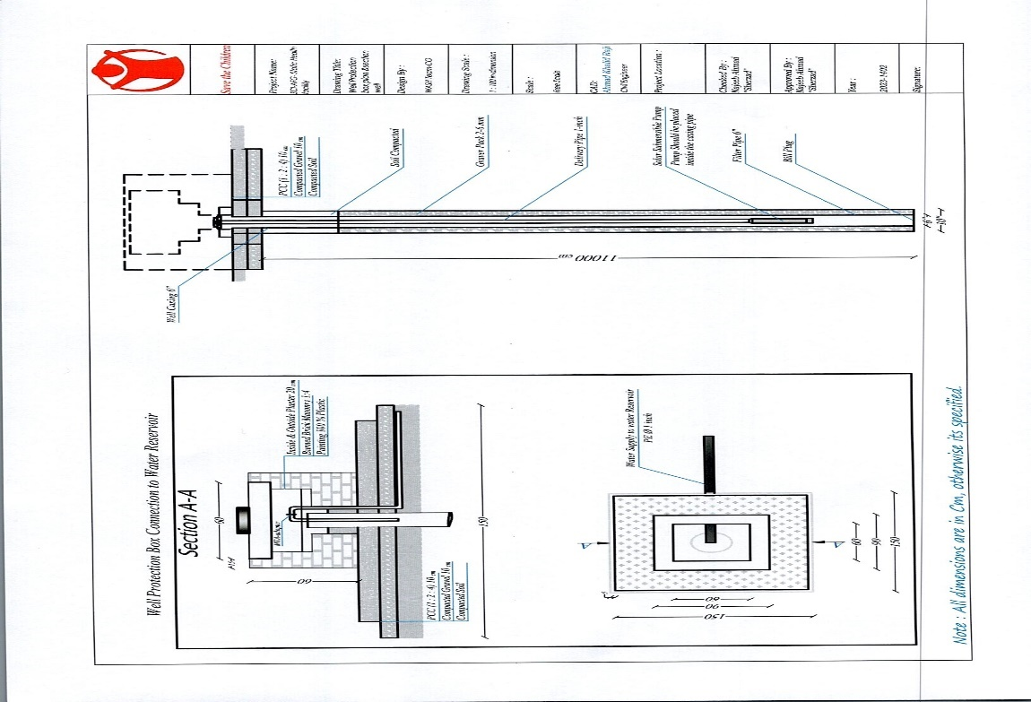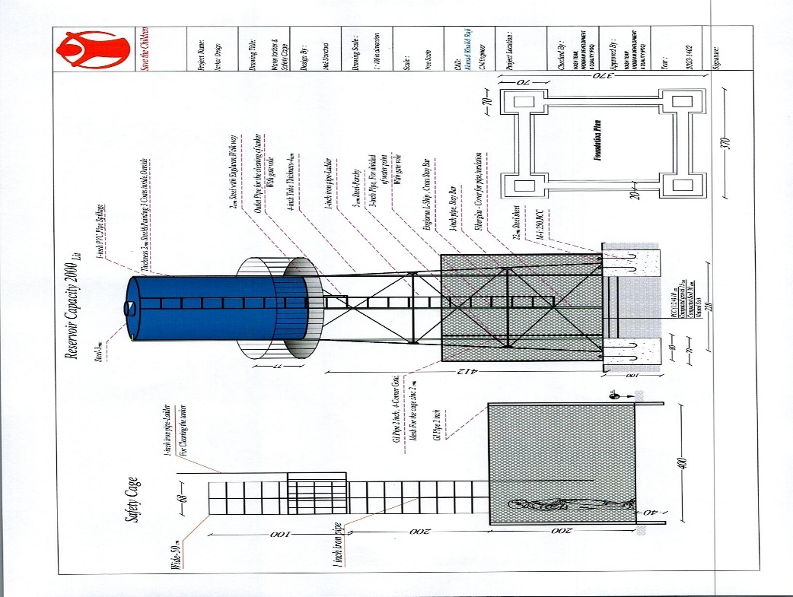

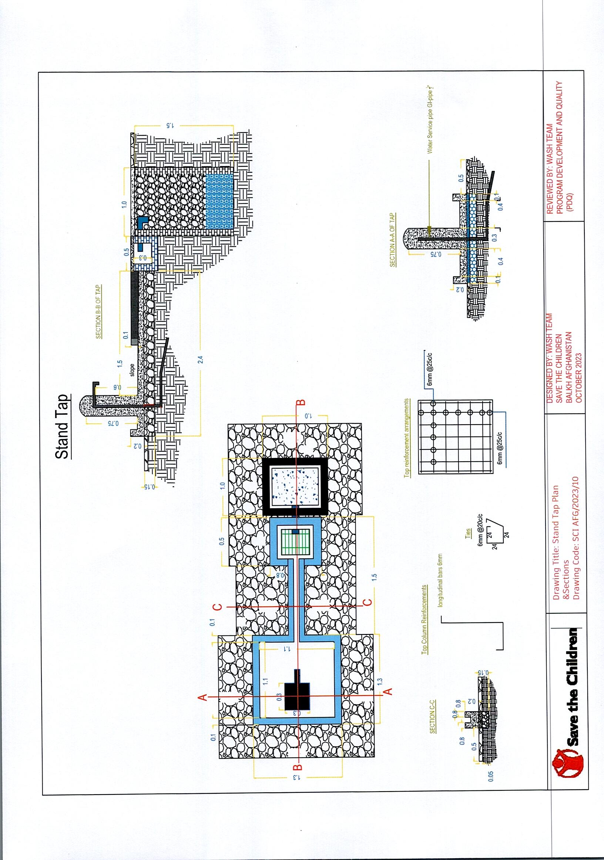

**(SADA KAS SHIRZAD)**

**Flash Latrine is made of burnt brick, and is for wheelchair users**

|  |  |  |  |  |  |  |
| --- | --- | --- | --- | --- | --- | --- |
| **Item** | **Items Description** | **Size/ Specification** | **Unit** | **Qty** | **Unit cost** | **Total** |
| 1 | Excavation | Foundation Excavation, cuttings and so on | m3 | 8.00 |  |  |
| 2 | Stone masonry 1:5 | Foundation stonemasonry up to under stairs and stairs with its landing | m3 | 2.90 |  |  |
| 3 | Stone patching | This is bold stone and will be lied on stairs (t = 2Ocm and t = 10 cm) before PCC layers | m3 | 0.74 |  |  |
| 4 | PCC 1:2:4 | PCC for foundations, stairs and its landing | m3 | 1.22 |  |  |
| 5 | Brick masonry | Brick masonry with cement sand mortar (1:4) and burnt brick must be used | m3 | 5.26 |  |  |
| 6 | Pointing | Point with cement and fine sand mortar(1:3) for apron stonemasonry | m2 | 3.00 |  |  |
| 7 | Plastering | Plastering with fine sand and cement with ration of 1:3 | m2 | 31.67 |  |  |
| 8 | Painting | plastic painting (100%) out and inside of the latrine | m2 | 31.67 |  |  |
| 9 | Angle Iron ( H-beam ), L = 270 cm | H beam having the cross section size ( H = B = 100mm, t1 = 8mm, and t2 = 6mm) unit weight 16.9 kg/m including transportation, welding and placing on the roof | Bar | 3.00 |  |  |
| 10 | Wooden timber (Khar) | Timber having minimum thickness of 3cm which should be laid on the poles based on drawings and details | m2 | 7.80 |  |  |
| 11 | Plastic sheet | 2 ply's having good quality | m2 | 7.80 |  |  |
| 12 | Roofing | Placing wooden poles, timbers, plastic sheet, placing soil, mud (Ghoragul) and soil and finally plastering with straw mud pestering in two layers based on the drawings and details | m2 | 7.80 |  |  |
| 13 | Wooden pole 1m length | wooden pole having a diameter of at least 10cm which is used as the latrine window lintel | Bar | 2.00 |  |  |
| 14 | Wooden pole 1.3m length | wooden pole having a diameter of at least 10cm which is used as the latrine door lintel | Bar | 2.00 |  |  |
| 15 | Tiles | Tiles size 30 x 30cm for floor and 30 x 60 for walls (h = 150cm) including labor work and material | m2 | 14.40 |  |  |
| 16 | Door | The metallic door must have a size of 100cm x 200cm including painting (3 coats), transportation, locks, hinges, handles (big one from inside and normal one from the outside), transportation and installation | pcs | 1.00 |  |  |
| 17 | Window | window with size70cm x 40cm including painting (3 coats), glass, handle, transportation and installation | pcs | 1.00 |  |  |
| 18 | Gutter | Gutter for rain and precipitations/flow | pcs | 2.00 |  |  |
| 19 | Rings | Made of PCC M150 having outer diameter of 100cm, inner diameter of 90cm and height of 40cm | pcs | 9.00 |  |  |
| 20 | Soak pit and Septic caps | made of RCC having outer diameter of 100cm, thickness of 10cm with a hole on top (Removable) | pcs | 2.00 |  |  |
| 21 | Pipe 2 inch | PVC class B | m | 8.00 |  |  |
| 22 | Elbow (PVC) | Elbow having angle of 90-degree 2 inch by 2 inch | pcs | 4.00 |  |  |
| 23 | Elbow (PVC) | Elbow having 90-degree 4 inch by 4 inch | pcs | 3.00 |  |  |
| 24 | Three way (PVC) | Three-way 2 inch by 2 inch by 2 inch having angle of 90 degree | pcs | 1.00 |  |  |
| 25 | Siphon 4 inch | PVC Elbow Schedule 40 siphon channel size 4-inch color white | pcs | 1.00 |  |  |
| 26 | Pipe 4 inch | PVC pipe 4-inch class B | m | 4.00 |  |  |
| 27 | Asian Toilet | Asian toilet not with its flash tank, because this latrine is not full flash | pcs | 1 |  |  |
| 28 | Grab Bars | For taking support for handicapped or ill persons | pcs | 2 |  |  |
| 29 | Hand washing sink | Hand washing sink including faucets or taps, mirror including transportation and installation including plumbing of all other components | pcs | 1 |  |  |
| 30 | Hand Rails | Hand rail made of round steel profile having diameter of 2 inches including painting 3 coats , transportation an and installations (see the attached drawings for more details) | m | 10 |  |  |
| 31 | Portable Toile chair | Portable Toilet Commode Chair, Portable Camping Toilet for Adults, Bedside Commodes, Stainless Steel Porta Potty with Backrest for Adults Suitable for Trips, Camping, Hiking, Home Use | pcs | 1 |  |  |
| 32 | Muslim Shower | A Muslim shower (also known as "bidet spray", "bidet sprayer", or "health faucet") is a hand-held triggered nozzle, similar to that on a kitchen sink sprayer, that delivers a spray of water to assist in anal cleansing and cleaning the genitals after defecation and urination | set | 1.00 |  |  |
| 33 | Water Storage/water tank | High Density Polyethylene (HDPE) storage tank having capacity of 500 liter with pipe, fittings, transportation and installation | set | 1.00 |  |  |
| 34 | Cloth hanger | Classic 5 X Double Hook Chrome Clothes Hanger | pcs | 1 |  |  |
| 35 | Cleaning Tools | toilet brush, squeegee with handle, mug, and trash bin | LS | 1 |  |  |
|  | **GRAND TOTAL ESTIMATED COST** | | **USD** | | |  |

**(Sorkh Dewal)**

**Flash Latrine is made of burnt brick, and is for wheelchair users**

|  |  |  |  |  |  |  |
| --- | --- | --- | --- | --- | --- | --- |
| **Item** | **Items Description** | **Size/ Specification** | **Unit** | **Qty** | **Unit cost** | **Total** |
| 1 | Excavation | Foundation Excavation, cuttings and so on | m3 | 8.00 |  |  |
| 2 | Stone masonry 1:5 | Foundation stonemasonry up to under stairs and stairs with its landing | m3 | 2.90 |  |  |
| 3 | Stone patching | This is bold stone and will be lied on stairs (t = 2Ocm and t = 10 cm) before PCC layers | m3 | 0.74 |  |  |
| 4 | PCC 1:2:4 | PCC for foundations, stairs and its landing | m3 | 1.22 |  |  |
| 5 | Brick masonry | Brick masonry with cement sand mortar (1:4) and burnt brick must be used | m3 | 5.26 |  |  |
| 6 | Pointing | Point with cement and fine sand mortar(1:3) for apron stonemasonry | m2 | 3.00 |  |  |
| 7 | Plastering | Plastering with fine sand and cement with ration of 1:3 | m2 | 31.67 |  |  |
| 8 | Painting | plastic painting (100%) out and inside of the latrine | m2 | 31.67 |  |  |
| 9 | Angle Iron ( H-beam ), L = 270 cm | H beam having the cross section size ( H = B = 100mm, t1 = 8mm, and t2 = 6mm) unit weight 16.9 kg/m including transportation, welding and placing on the roof | Bar | 3.00 |  |  |
| 10 | Wooden timber (Khar) | Timber having minimum thickness of 3cm which should be laid on the poles based on drawings and details | m2 | 7.80 |  |  |
| 11 | Plastic sheet | 2 ply's having good quality | m2 | 7.80 |  |  |
| 12 | Roofing | Placing wooden poles, timbers, plastic sheet, placing soil, mud (Ghoragul) and soil and finally plastering with straw mud pestering in two layers based on the drawings and details | m2 | 7.80 |  |  |
| 13 | Wooden pole 1m length | wooden pole having a diameter of at least 10cm which is used as the latrine window lintel | Bar | 2.00 |  |  |
| 14 | Wooden pole 1.3m length | wooden pole having a diameter of at least 10cm which is used as the latrine door lintel | Bar | 2.00 |  |  |
| 15 | Tiles | Tiles size 30 x 30cm for floor and 30 x 60 for walls (h = 150cm) including labor work and material | m2 | 14.40 |  |  |
| 16 | Door | The metallic door must have a size of 100cm x 200cm including painting (3 coats), transportation, locks, hinges, handles (big one from inside and normal one from the outside), transportation and installation | pcs | 1.00 |  |  |
| 17 | Window | window with size70cm x 40cm including painting (3 coats), glass, handle, transportation and installation | pcs | 1.00 |  |  |
| 18 | Gutter | Gutter for rain and precipitations/flow | pcs | 2.00 |  |  |
| 19 | Rings | Made of PCC M150 having outer diameter of 100cm, inner diameter of 90cm and height of 40cm | pcs | 9.00 |  |  |
| 20 | Soak pit and Septic caps | made of RCC having outer diameter of 100cm, thickness of 10cm with a hole on top (Removable) | pcs | 2.00 |  |  |
| 21 | Pipe 2 inch | PVC class B | m | 8.00 |  |  |
| 22 | Elbow (PVC) | Elbow having angle of 90-degree 2 inch by 2 inch | pcs | 4.00 |  |  |
| 23 | Elbow (PVC) | Elbow having 90-degree 4 inch by 4 inch | pcs | 3.00 |  |  |
| 24 | Three way (PVC) | Three-way 2 inch by 2 inch by 2 inch having angle of 90 degree | pcs | 1.00 |  |  |
| 25 | Siphon 4 inch | PVC Elbow Schedule 40 siphon channel size 4-inch color white | pcs | 1.00 |  |  |
| 26 | Pipe 4 inch | PVC pipe 4-inch class B | m | 4.00 |  |  |
| 27 | Asian Toilet | Asian toilet not with its flash tank, because this latrine is not full flash | pcs | 1 |  |  |
| 28 | Grab Bars | For taking support for handicapped or ill persons | pcs | 2 |  |  |
| 29 | Hand washing sink | Hand washing sink including faucets or taps, mirror including transportation and installation including plumbing of all other components | pcs | 1 |  |  |
| 30 | Hand Rails | Hand rail made of round steel profile having diameter of 2 inches including painting 3 coats , transportation an and installations (see the attached drawings for more details) | m | 10 |  |  |
| 31 | Portable Toile chair | Portable Toilet Commode Chair, Portable Camping Toilet for Adults, Bedside Commodes, Stainless Steel Porta Potty with Backrest for Adults Suitable for Trips, Camping, Hiking, Home Use | pcs | 1 |  |  |
| 32 | Muslim Shower | A Muslim shower (also known as "bidet spray", "bidet sprayer", or "health faucet") is a hand-held triggered nozzle, similar to that on a kitchen sink sprayer, that delivers a spray of water to assist in anal cleansing and cleaning the genitals after defecation and urination | set | 1.00 |  |  |
| 33 | Water Storage/water tank | High Density Polyethylene (HDPE) storage tank having capacity of 500 liter with pipe, fittings, transportation and installation | set | 1.00 |  |  |
| 34 | Cloth hanger | Classic 5 X Double Hook Chrome Clothes Hanger | pcs | 1 |  |  |
| 35 | Cleaning Tools | toilet brush, squeegee with handle, mug, and trash bin | LS | 1 |  |  |
|  | **GRAND TOTAL ESTIMATED COST** | | **USD** | | |  |

**(Sorkhab Achin)**

**Flash Latrine is made of burnt brick, and is for wheelchair users**

|  |  |  |  |  |  |  |
| --- | --- | --- | --- | --- | --- | --- |
| **Item** | **Items Description** | **Size/ Specification** | **Unit** | **Qty** | **Unit cost** | **Total** |
| 1 | Excavation | Foundation Excavation, cuttings and so on | m3 | 8.00 |  |  |
| 2 | Stone masonry 1:5 | Foundation stonemasonry up to under stairs and stairs with its landing | m3 | 2.90 |  |  |
| 3 | Stone patching | This is bold stone and will be lied on stairs (t = 2Ocm and t = 10 cm) before PCC layers | m3 | 0.74 |  |  |
| 4 | PCC 1:2:4 | PCC for foundations, stairs and its landing | m3 | 1.22 |  |  |
| 5 | Brick masonry | Brick masonry with cement sand mortar (1:4) and burnt brick must be used | m3 | 5.26 |  |  |
| 6 | Pointing | Point with cement and fine sand mortar(1:3) for apron stonemasonry | m2 | 3.00 |  |  |
| 7 | Plastering | Plastering with fine sand and cement with ration of 1:3 | m2 | 31.67 |  |  |
| 8 | Painting | plastic painting (100%) out and inside of the latrine | m2 | 31.67 |  |  |
| 9 | Angle Iron ( H-beam ), L = 270 cm | H beam having the cross section size ( H = B = 100mm, t1 = 8mm, and t2 = 6mm) unit weight 16.9 kg/m including transportation, welding and placing on the roof | Bar | 3.00 |  |  |
| 10 | Wooden timber (Khar) | Timber having minimum thickness of 3cm which should be laid on the poles based on drawings and details | m2 | 7.80 |  |  |
| 11 | Plastic sheet | 2 ply's having good quality | m2 | 7.80 |  |  |
| 12 | Roofing | Placing wooden poles, timbers, plastic sheet, placing soil, mud (Ghoragul) and soil and finally plastering with straw mud pestering in two layers based on the drawings and details | m2 | 7.80 |  |  |
| 13 | Wooden pole 1m length | wooden pole having a diameter of at least 10cm which is used as the latrine window lintel | Bar | 2.00 |  |  |
| 14 | Wooden pole 1.3m length | wooden pole having a diameter of at least 10cm which is used as the latrine door lintel | Bar | 2.00 |  |  |
| 15 | Tiles | Tiles size 30 x 30cm for floor and 30 x 60 for walls (h = 150cm) including labor work and material | m2 | 14.40 |  |  |
| 16 | Door | The metallic door must have a size of 100cm x 200cm including painting (3 coats), transportation, locks, hinges, handles (big one from inside and normal one from the outside), transportation and installation | pcs | 1.00 |  |  |
| 17 | Window | window with size70cm x 40cm including painting (3 coats), glass, handle, transportation and installation | pcs | 1.00 |  |  |
| 18 | Gutter | Gutter for rain and precipitations/flow | pcs | 2.00 |  |  |
| 19 | Rings | Made of PCC M150 having outer diameter of 100cm, inner diameter of 90cm and height of 40cm | pcs | 9.00 |  |  |
| 20 | Soak pit and Septic caps | made of RCC having outer diameter of 100cm, thickness of 10cm with a hole on top (Removable) | pcs | 2.00 |  |  |
| 21 | Pipe 2 inch | PVC class B | m | 8.00 |  |  |
| 22 | Elbow (PVC) | Elbow having angle of 90-degree 2 inch by 2 inch | pcs | 4.00 |  |  |
| 23 | Elbow (PVC) | Elbow having 90-degree 4 inch by 4 inch | pcs | 3.00 |  |  |
| 24 | Three way (PVC) | Three-way 2 inch by 2 inch by 2 inch having angle of 90 degree | pcs | 1.00 |  |  |
| 25 | Siphon 4 inch | PVC Elbow Schedule 40 siphon channel size 4-inch color white | pcs | 1.00 |  |  |
| 26 | Pipe 4 inch | PVC pipe 4-inch class B | m | 4.00 |  |  |
| 27 | Asian Toilet | Asian toilet not with its flash tank, because this latrine is not full flash | pcs | 1 |  |  |
| 28 | Grab Bars | For taking support for handicapped or ill persons | pcs | 2 |  |  |
| 29 | Hand washing sink | Hand washing sink including faucets or taps, mirror including transportation and installation including plumbing of all other components | pcs | 1 |  |  |
| 30 | Hand Rails | Hand rail made of round steel profile having diameter of 2 inches including painting 3 coats , transportation an and installations (see the attached drawings for more details) | m | 10 |  |  |
| 31 | Portable Toile chair | Portable Toilet Commode Chair, Portable Camping Toilet for Adults, Bedside Commodes, Stainless Steel Porta Potty with Backrest for Adults Suitable for Trips, Camping, Hiking, Home Use | pcs | 1 |  |  |
| 32 | Muslim Shower | A Muslim shower (also known as "bidet spray", "bidet sprayer", or "health faucet") is a hand-held triggered nozzle, similar to that on a kitchen sink sprayer, that delivers a spray of water to assist in anal cleansing and cleaning the genitals after defecation and urination | set | 1.00 |  |  |
| 33 | Water Storage/water tank | High Density Polyethylene (HDPE) storage tank having capacity of 500 liter with pipe, fittings, transportation and installation | set | 1.00 |  |  |
| 34 | Cloth hanger | Classic 5 X Double Hook Chrome Clothes Hanger | pcs | 1 |  |  |
| 35 | Cleaning Tools | toilet brush, squeegee with handle, mug, and trash bin | LS | 1 |  |  |
|  | **GRAND TOTAL ESTIMATED COST** | | **USD** | | |  |

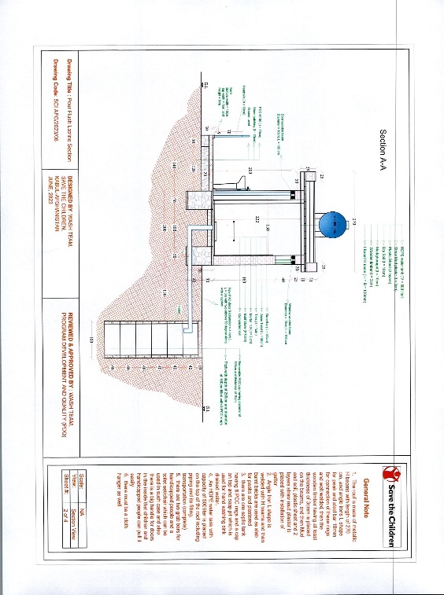

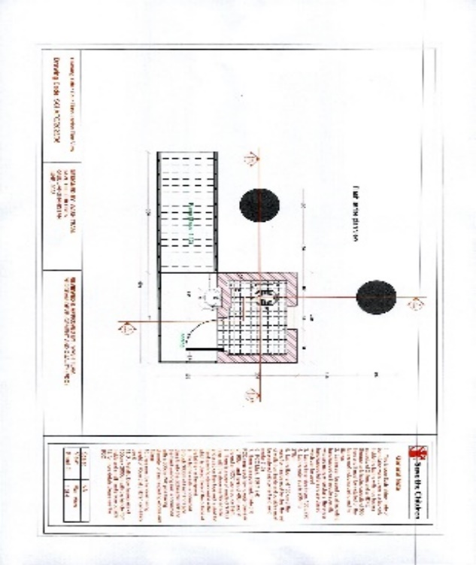

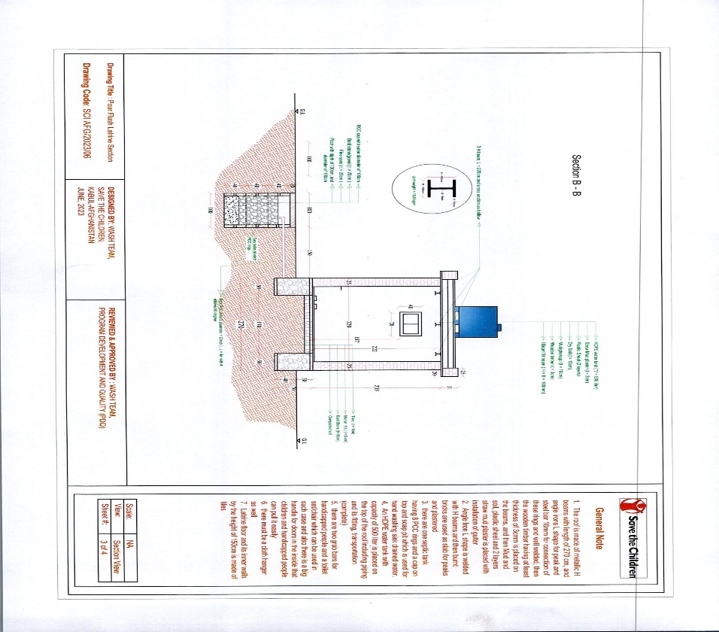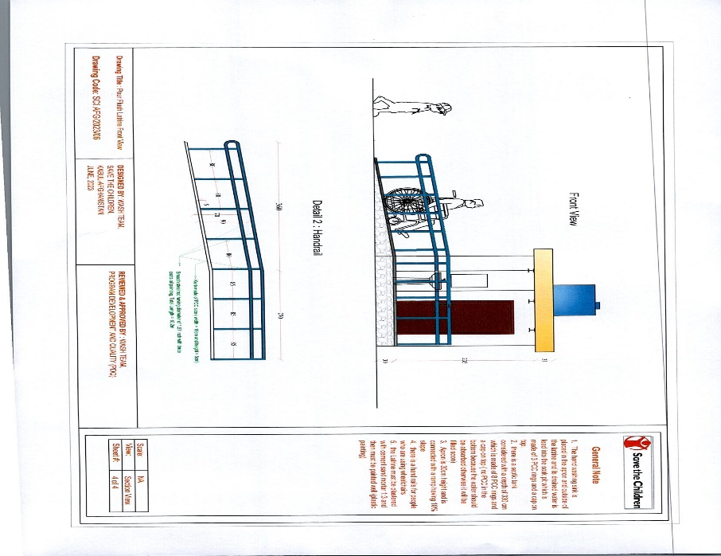

**(SADA KAS SHIRZAD)**

**Handwashing station for BHC-SCI**

|  |  |  |  |  |  |
| --- | --- | --- | --- | --- | --- |
| **Handwashing station for BHC-SCI** | | | | | |
| **No** | **Description** | **Quantity** | **Unit** | **Items Unit price USD** | **Total USD** |
| 1 | Site preparation and site cleaning/leveling | 4 | m2 |  |  |
| 2 | PCC M150 (Thickness 5cm based on drawings) | 0.2 | m3 |  |  |
| 3 | Stone patching (thickness = 10cm based on drawings) | 0.4 | m3 |  |  |
| 4 | Cylindrical water tank with capacity of one cubic meter/1000 liter made of galvanized iron sheet having at least 2mm thickness. There should be two outlets having diameter of 2 inches with 2 control valves, 3m of steel pipe with diameter of 2 inches installed with 5 pieces of ¾ brass taps, one inlet and one overflow having diameter of one inch based on the attached drawings. Pedestal height should be 40cm from the ground level and made of L shape profile not iron sheet. All necessary tools such as reducers, connections and elbows are included. | 1 | Piece |  |  |
| 5 | Soak Pit for wastewater | 1 | Pit |  |  |
|  | **Total cost of one handwash station including one tanker** | **USD** |  |  |  |

**(Sorkh Dewal)**

**Handwashing station for BHC-SCI**

|  |  |  |  |  |  |
| --- | --- | --- | --- | --- | --- |
| **Handwashing station for BHC-SCI** | | | | | |
| **No** | **Description** | **Quantity** | **Unit** | **Items Unit price USD** | **Total USD** |
| 1 | Site preparation and site cleaning/leveling | 4 | m2 |  |  |
| 2 | PCC M150 (Thickness 5cm based on drawings) | 0.2 | m3 |  |  |
| 3 | Stone patching (thickness = 10cm based on drawings) | 0.4 | m3 |  |  |
| 4 | Cylindrical water tank with capacity of one cubic meter/1000 liter made of galvanized iron sheet having at least 2mm thickness. There should be two outlets having diameter of 2 inches with 2 control valves, 3m of steel pipe with diameter of 2 inches installed with 5 pieces of ¾ brass taps, one inlet and one overflow having diameter of one inch based on the attached drawings. Pedestal height should be 40cm from the ground level and made of L shape profile not iron sheet. All necessary tools such as reducers, connections and elbows are included. | 1 | Piece |  |  |
| 5 | Soak Pit for wastewater | 1 | Pit |  |  |
|  | **Total cost of one handwash station including one tanker** | **USD** |  |  |  |

**(Sorkhab Achin)**

**Handwashing station for BHC-SCI**

|  |  |  |  |  |  |
| --- | --- | --- | --- | --- | --- |
| **Handwashing station for BHC-SCI** | | | | | |
| **No** | **Description** | **Quantity** | **Unit** | **Items Unit price USD** | **Total USD** |
| 1 | Site preparation and site cleaning/leveling | 4 | m2 |  |  |
| 2 | PCC M150 (Thickness 5cm based on drawings) | 0.2 | m3 |  |  |
| 3 | Stone patching (thickness = 10cm based on drawings) | 0.4 | m3 |  |  |
| 4 | Cylindrical water tank with capacity of one cubic meter/1000 liter made of galvanized iron sheet having at least 2mm thickness. There should be two outlets having diameter of 2 inches with 2 control valves, 3m of steel pipe with diameter of 2 inches installed with 5 pieces of ¾ brass taps, one inlet and one overflow having diameter of one inch based on the attached drawings. Pedestal height should be 40cm from the ground level and made of L shape profile not iron sheet. All necessary tools such as reducers, connections and elbows are included. | 1 | Piece |  |  |
| 5 | Soak Pit for wastewater | 1 | Pit |  |  |
|  | **Total cost of one handwash station including one tanker** | **USD** |  |  |  |

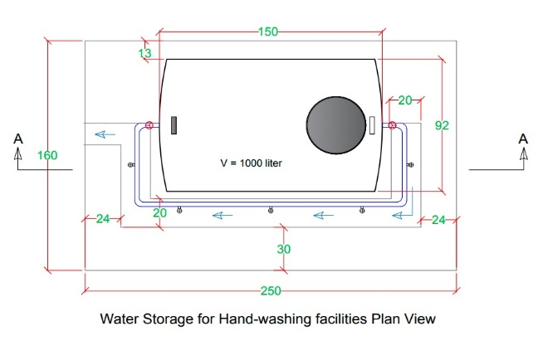

**(SADA KAS SHIRZAD)**

**Construction of waste pit in BHC**

|  |  |  |  |  |  |  |
| --- | --- | --- | --- | --- | --- | --- |
| **Construction of waste pit in BHC** | | | | | | |
| **SNO** | **Item** | **Description** | **Unit** | **Quantity** | **Unit cost USD** | **Sub-total price USD** |
| **1** | **Pit Excavation** | **Pitches with depth of 4.1m and 1.4m of diameter** | **m3** | **6.3** |  |  |
| **2** | **PCC Concrete** | **Placement of PCC concrete around the pit on top and bottom of the pit.** | **m3** | **0.5** |  |  |
| **3** | **RCC Rings** | **concrete rings having inner diameter of 80cm, outer diameter of 90cm, height of 40cm, thickness of 5cm and having three layers of steel bars with diameter of 6mm** | **Piece** | **10** |  |  |
| **4** | **Waste Pit Cap** | **made of RCC having outer diameter of 100cm, thickness of 10cm with a hole on top ( Removable )** | **pcs** | **1** |  |  |
|  |  |  |  |  | **TOTAL** |  |

**(Sorkh Dewal)**

**Construction of waste pit in BHC**

|  |  |  |  |  |  |  |
| --- | --- | --- | --- | --- | --- | --- |
| **Construction of waste pit in BHC** | | | | | | |
| **SNO** | **Item** | **Description** | **Unit** | **Quantity** | **Unit cost USD** | **Sub-total price USD** |
| **1** | **Pit Excavation** | **Pitches with depth of 4.1m and 1.4m of diameter** | **m3** | **6.3** |  |  |
| **2** | **PCC Concrete** | **Placement of PCC concrete around the pit on top and bottom of the pit.** | **m3** | **0.5** |  |  |
| **3** | **RCC Rings** | **concrete rings having inner diameter of 80cm, outer diameter of 90cm, height of 40cm, thickness of 5cm and having three layers of steel bars with diameter of 6mm** | **Piece** | **10** |  |  |
| **4** | **Waste Pit Cap** | **made of RCC having outer diameter of 100cm, thickness of 10cm with a hole on top ( Removable )** | **pcs** | **1** |  |  |
|  |  |  |  |  | **TOTAL** |  |

**(Sorkhab Achin)**

**Construction of waste pit in BHC**

|  |  |  |  |  |  |  |
| --- | --- | --- | --- | --- | --- | --- |
| **Construction of waste pit in BHC** | | | | | | |
| **SNO** | **Item** | **Description** | **Unit** | **Quantity** | **Unit cost USD** | **Sub-total price USD** |
| **1** | **Pit Excavation** | **Pitches with depth of 4.1m and 1.4m of diameter** | **m3** | **6.3** |  |  |
| **2** | **PCC Concrete** | **Placement of PCC concrete around the pit on top and bottom of the pit.** | **m3** | **0.5** |  |  |
| **3** | **RCC Rings** | **concrete rings having inner diameter of 80cm, outer diameter of 90cm, height of 40cm, thickness of 5cm and having three layers of steel bars with diameter of 6mm** | **Piece** | **10** |  |  |
| **4** | **Waste Pit Cap** | **made of RCC having outer diameter of 100cm, thickness of 10cm with a hole on top ( Removable )** | **pcs** | **1** |  |  |
|  |  |  |  |  | **TOTAL** |  |

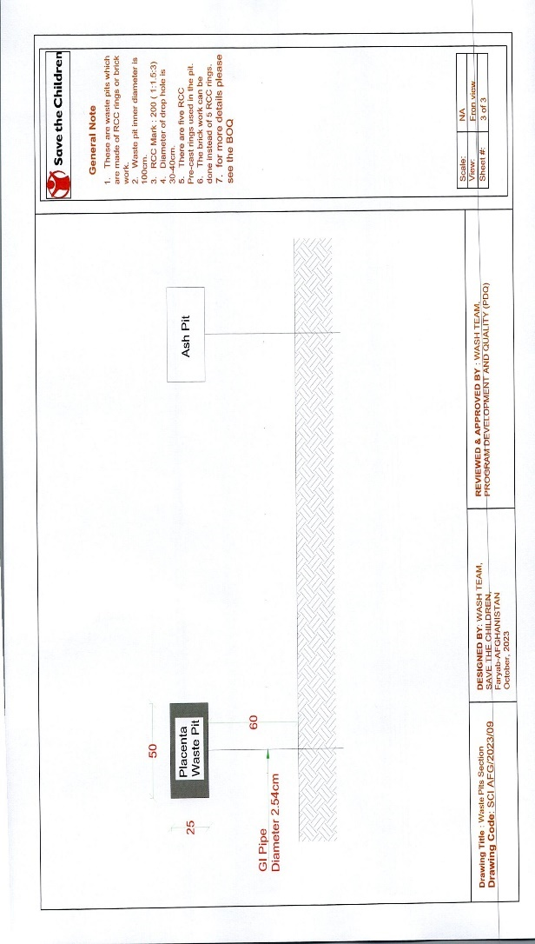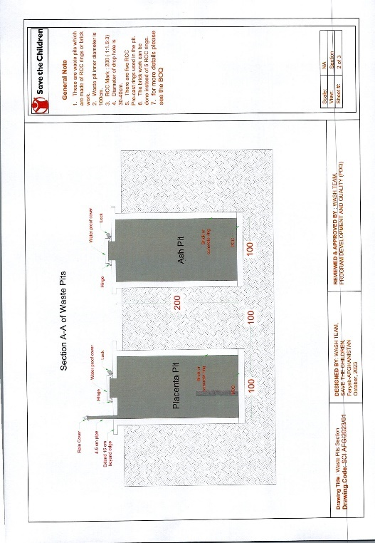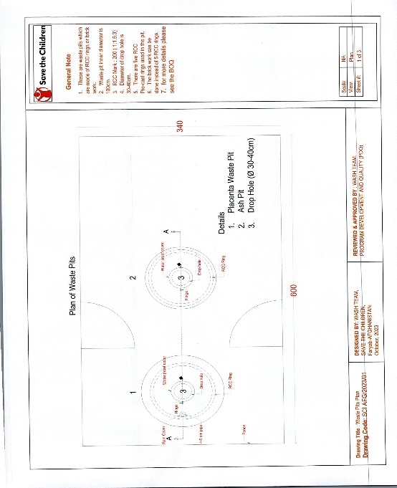

**(SADA KAS SHIRZAD)**

**Solar Power system for Static Health Facility**

|  |  |  |  |  |  |  |
| --- | --- | --- | --- | --- | --- | --- |
| **Item** | **Items Description** | **Size/ Specification** | **Unit** | **Qty** | **Unit cost USD** | **Total** |
| 1 | Sorotec Inverter Hybrid 5kw | Sorotec Inverter Hybrid 5kw 48vDC 145v 2 years Warranty | Pcs | 3 |  |  |
| 2 | Jinko Solar panel 545w 144cell | Model Jinko Solar panel 545w Mono PERC-144(HC) High-efficiency 10 years warranty | Pcs | 28 |  |  |
| 3 | Solar panels stand steel | Solar panels stand steel profile (80*80)mm and Profile (40*80)mm Thick 1.5mm and 30-35 degree Large (panels support structure ) | set | 28 |  |  |
| 4 | cable (4*6)mm | cable (4*6)mm from panels to Inverter | m | 100 |  |  |
| 5 | Power Cable (2*16)mm2 | Power Cable (2*16)mm2 from Solar panels to Inverter | m | 120 |  |  |
| 6 | cable 1*6mm | cable 1*6mm for solar connections | m | 100 |  |  |
| 7 | Tall Battery | Tall Battery ADDO Tubular 220 Ah 12v | Pcs | 3 |  |  |
| 8 | Ground Rod With Copper Cable | Ground Rod With Copper Cable | set | 1 |  |  |
| 9 | Battery frame | Battery frame for 3 piece | set | 1 |  |  |
| 10 | Electrical conduit Pipe | Electrical conduit Pipe for external power Cables | set | 100 |  |  |
| 11 | Wire Tie white and black | Wire Tie white and black | set | 2 |  |  |
| 12 | Supply and Installation of solar panels | Supply and Installation of solar panels | ls | 1 |  |  |
| 13 | Main switch for solar | Main switch for solar to Inverter DC v 800v 100 AH | Pcs | 1 |  |  |
| 14 | Campus Lights | Solar based street wall mounted light with 1.5" GI column for campus and corner of building (60 Watt) | Pcs | 10 |  |  |
| 15 | Bioler 80 liter | Bioler 80 liter with power need of 2000 watt | Pcs | 2 |  |  |
| 16 | AC | AC with power need of 1200 BTU | Pcs | 1 |  |  |
| 17 | Heater | Heater with power need of 2500 watt | Pcs | 2 |  |  |
| 18 | Washing Machine | Washing machine with capacity of 700 Watt | Pcs | 1 |  |  |
| 19 | Fans | Fans celling / wall | Pcs | 10 |  |  |
| 20 | Refrigerator | Refrigerator Medium size | Pcs | 1 |  |  |
|  | **GRAND TOTAL ESTIMATED COST** | | **USD** | | |  |

**(Sorkh Dewal)**

**Solar Power system for Static Health Facility**

|  |  |  |  |  |  |  |
| --- | --- | --- | --- | --- | --- | --- |
| **Item** | **Items Description** | **Size/ Specification** | **Unit** | **Qty** | **Unit cost USD** | **Total** |
| 1 | Sorotec Inverter Hybrid 5kw | Sorotec Inverter Hybrid 5kw 48vDC 145v 2 years Warranty | Pcs | 3 |  |  |
| 2 | Jinko Solar panel 545w 144cell | Model Jinko Solar panel 545w Mono PERC-144(HC) High-efficiency 10 years warranty | Pcs | 28 |  |  |
| 3 | Solar panels stand steel | Solar panels stand steel profile (80*80)mm and Profile (40*80)mm Thick 1.5mm and 30-35 degree Large (panels support structure ) | set | 28 |  |  |
| 4 | cable (4*6)mm | cable (4*6)mm from panels to Inverter | m | 100 |  |  |
| 5 | Power Cable (2*16)mm2 | Power Cable (2*16)mm2 from Solar panels to Inverter | m | 120 |  |  |
| 6 | cable 1*6mm | cable 1*6mm for solar connections | m | 100 |  |  |
| 7 | Tall Battery | Tall Battery ADDO Tubular 220 Ah 12v | Pcs | 3 |  |  |
| 8 | Ground Rod With Copper Cable | Ground Rod With Copper Cable | set | 1 |  |  |
| 9 | Battery frame | Battery frame for 3 piece | set | 1 |  |  |
| 10 | Electrical conduit Pipe | Electrical conduit Pipe for external power Cables | set | 100 |  |  |
| 11 | Wire Tie white and black | Wire Tie white and black | set | 2 |  |  |
| 12 | Supply and Installation of solar panels | Supply and Installation of solar panels | ls | 1 |  |  |
| 13 | Main switch for solar | Main switch for solar to Inverter DC v 800v 100 AH | Pcs | 1 |  |  |
| 14 | Campus Lights | Solar based street wall mounted light with 1.5" GI column for campus and corner of building (60 Watt) | Pcs | 10 |  |  |
| 15 | Bioler 80 liter | Bioler 80 liter with power need of 2000 watt | Pcs | 2 |  |  |
| 16 | AC | AC with power need of 1200 BTU | Pcs | 1 |  |  |
| 17 | Heater | Heater with power need of 2500 watt | Pcs | 2 |  |  |
| 18 | Washing Machine | Washing machine with capacity of 700 Watt | Pcs | 1 |  |  |
| 19 | Fans | Fans celling / wall | Pcs | 10 |  |  |
| 20 | Refrigerator | Refrigerator Medium size | Pcs | 1 |  |  |
|  | **GRAND TOTAL ESTIMATED COST** | | **USD** | | |  |

**(Sorkhab Achin)**

**Solar Power system for Static Health Facility**

|  |  |  |  |  |  |  |
| --- | --- | --- | --- | --- | --- | --- |
| **Item** | **Items Description** | **Size/ Specification** | **Unit** | **Qty** | **Unit cost USD** | **Total** |
| 1 | Sorotec Inverter Hybrid 5kw | Sorotec Inverter Hybrid 5kw 48vDC 145v 2 years Warranty | Pcs | 3 |  |  |
| 2 | Jinko Solar panel 545w 144cell | Model Jinko Solar panel 545w Mono PERC-144(HC) High-efficiency 10 years warranty | Pcs | 28 |  |  |
| 3 | Solar panels stand steel | Solar panels stand steel profile (80*80)mm and Profile (40*80)mm Thick 1.5mm and 30-35 degree Large (panels support structure ) | set | 28 |  |  |
| 4 | cable (4*6)mm | cable (4*6)mm from panels to Inverter | m | 100 |  |  |
| 5 | Power Cable (2*16)mm2 | Power Cable (2*16)mm2 from Solar panels to Inverter | m | 120 |  |  |
| 6 | cable 1*6mm | cable 1*6mm for solar connections | m | 100 |  |  |
| 7 | Tall Battery | Tall Battery ADDO Tubular 220 Ah 12v | Pcs | 3 |  |  |
| 8 | Ground Rod With Copper Cable | Ground Rod With Copper Cable | set | 1 |  |  |
| 9 | Battery frame | Battery frame for 3 piece | set | 1 |  |  |
| 10 | Electrical conduit Pipe | Electrical conduit Pipe for external power Cables | set | 100 |  |  |
| 11 | Wire Tie white and black | Wire Tie white and black | set | 2 |  |  |
| 12 | Supply and Installation of solar panels | Supply and Installation of solar panels | ls | 1 |  |  |
| 13 | Main switch for solar | Main switch for solar to Inverter DC v 800v 100 AH | Pcs | 1 |  |  |
| 14 | Campus Lights | Solar based street wall mounted light with 1.5" GI column for campus and corner of building (60 Watt) | Pcs | 10 |  |  |
| 15 | Bioler 80 liter | Bioler 80 liter with power need of 2000 watt | Pcs | 2 |  |  |
| 16 | AC | AC with power need of 1200 BTU | Pcs | 1 |  |  |
| 17 | Heater | Heater with power need of 2500 watt | Pcs | 2 |  |  |
| 18 | Washing Machine | Washing machine with capacity of 700 Watt | Pcs | 1 |  |  |
| 19 | Fans | Fans celling / wall | Pcs | 10 |  |  |
| 20 | Refrigerator | Refrigerator Medium size | Pcs | 1 |  |  |
|  | **GRAND TOTAL ESTIMATED COST** | | **USD** | | |  |

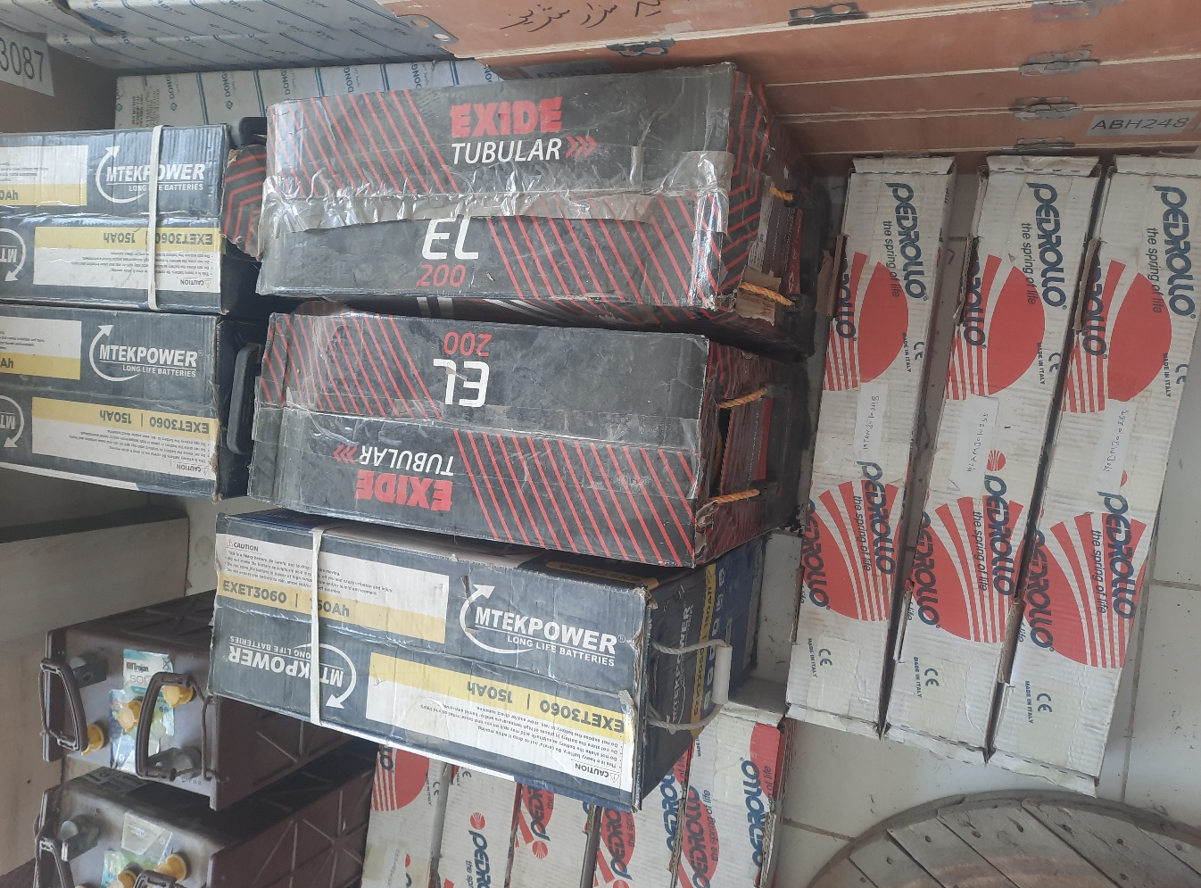

**(SADA KAS SHIRZAD)**

**Water Purification and Facility Disinfection Supplies**

|  |  |  |  |  |  |  |
| --- | --- | --- | --- | --- | --- | --- |
| **Item** | **Items Description** | **Size/ Specification** | **Unit** | **Qty** | **Unit cost USD** | **Total USD** |
| 1 | Aqua Tabs | Procurement of water purification chemicals (chlorine) | Strips | 2000 |  |  |
| 2 | Pool Testers | Pool tester kits and consumables | No | 3 |  |  |
| 3 | Chlorine | Disinfection of health facility | Kg | 54 |  |  |
|  | **GRAND TOTAL ESTIMATED COST** | | **USD** | | |  |

**(Sorkh dewal)**

**Water Purification and Facility Disinfection Supplies**

|  |  |  |  |  |  |  |
| --- | --- | --- | --- | --- | --- | --- |
| **Item** | **Items Description** | **Size/ Specification** | **Unit** | **Qty** | **Unit cost USD** | **Total USD** |
| 1 | Aqua Tabs | Procurement of water purification chemicals (chlorine) | Strips | 2000 |  |  |
| 2 | Pool Testers | Pool tester kits and consumables | No | 3 |  |  |
| 3 | Chlorine | Disinfection of health facility | Kg | 54 |  |  |
|  | **GRAND TOTAL ESTIMATED COST** | | **USD** | | |  |

**(Sorkhab Achin)**

**Water Purification and Facility Disinfection Supplies**

|  |  |  |  |  |  |  |
| --- | --- | --- | --- | --- | --- | --- |
| **Item** | **Items Description** | **Size/ Specification** | **Unit** | **Qty** | **Unit cost USD** | **Total USD** |
| 1 | Aqua Tabs | Procurement of water purification chemicals (chlorine) | Strips | 2000 |  |  |
| 2 | Pool Testers | Pool tester kits and consumables | No | 3 |  |  |
| 3 | Chlorine | Disinfection of health facility | Kg | 54 |  |  |
|  | **GRAND TOTAL ESTIMATED COST** | | **USD** | | |  |

## **SECTION 4 – BIDDER SUBMISSION CHECKLIST**

|  |  |  |  |  |  |  |
| --- | --- | --- | --- | --- | --- | --- |
| **We, the Bidder, hereby confirm we have completed all sections of the Bidder Response Document:** | | | | | | |
| **No** | **Section** | | | **Please Tick** | | |
| 1. | Section 1 – Essential Criteria | | |  | | |
| 2. | Section 2 – Capability & Sustainability Questions | | |  | | |
| 3. | Section 3 – Commercial Questions | | |  | | |
|  | | | | | | |
| **We, the Bidder, confirm we have uploaded all of the required information and supporting evidence:** | | | | | | |
| **Section** | | **Required Document / Evidence** | | | | **Please Tick** |
| **Essential Criteria Evidence** | | Proof of legitimate business address | | | |  |
|  | | Copy of tax registration number & certificate | | | |  |
|  | | Copy of business registration certificate | | | |  |
|  | | Copy of Trading License | | | |  |
|  | | Certificate or other relevant registration from national bodies (e.g. ministry of works). | | | |  |
| **Capability Criteria Evidence** | | Completed Bidder Response Document | | | |  |
|  | | Supporting Financial Documents | | | |  |
|  | | Work Plan Proposal | | | |  |
|  | | Methodology Proposal | | | |  |
|  | | Financial Accounts | | | |  |
|  | | Organogram and Key Staff CV’s | | | |  |
| **Commercial Criteria Evidence** | | Completed Bidder Response Document | | | |  |
|  | | | | | | |
| **We, the Bidder, hereby confirm we compliance with the following policies and requirements:** | | | | | | |
| **Policy** | | | **Policy / Document** | | **Signature** | |
| Terms & Conditions of Bidding | | |  | |  | |
| Terms & Conditions of Purchase | | |  | |  | |
| Supplier Sustainability Policy  and the included mandatory policies | | | [Click Here to Access](https://www.savethechildren.net/sites/www.savethechildren.net/files/Supplier%20Sustainability%20Policy.pdf) | |  | |

|  |  |
| --- | --- |
| We confirm that Save the Children may in its consideration of our offer, and subsequently, rely on the statements made herein. | |
| Signature: | ………………………………………………….. |
| Name: | ………………………………………………….. |
| Title: | ………………………………………………….. |
| Company: | ………………………………………………….. |
| Date: | ………………………………………………….. |